TROUBLED WATERS
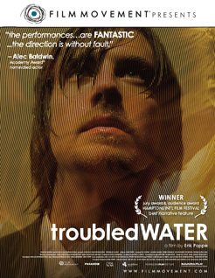
Norway, 2009, d. Erik Poppe

(UNRATED)

A moving film.

Troubled Waters takes its title from Paul Simon's song which is played twice during a crucial scene and its repetition. The troubled waters are evident. However, the full title of the song is Bridge over Troubled Waters and exploring that theme opens up the drama and the spiritual dimensions of the drama.

Here is a film which is commercially interesting but which incorporates into its plot aspects of Lutheran spirituality and practise without embarrassment. Norway, even though like other European countries it is marked by an increasing secularism, has a Lutheran tradition which is part of its heritage and, as the film indicates, can contribute to religion, morality and to its culture.

The film is in two parts. We see an abduction of a child as the film opens. There are painful consequences. One of the young men responsible (though he won't admit it) is released from jail and finds a job as an organist at a local church. The first part of the film is the young man's story, of his being rehabilitated, becoming friendly with the local priest. She has a young son (presented as a mirror image of the abducted boy). The second part of the film takes up the abduction once again and we follow the life of the family, especially the mother, whose son was taken. Each story has two sides and the second part fills in detail of what we have seen in the young man's story. The climax brings the man and the mother together to face what took place.

The mother is distraught and the effects of the tragedy are very deep in her. She needs to hear what actually happened to her son before she is able to consider any kind of forgiveness.

The screenplay draws attention to themes of forgiveness but also of atonement. Confessing, and the inability to confess, are significant. Communion is seen as a step in healing brokenness. And, despite what the young man has done, the manager of the church business has to tell the mother that, in terms of second chances, where else can this be done best but in the church.

The film has been made with elegant craft, has several sequences of organ music, but tells a story of everyday headlines and the lives behind the headlines, with both insight and a challenge to the possibilities for compassion.

