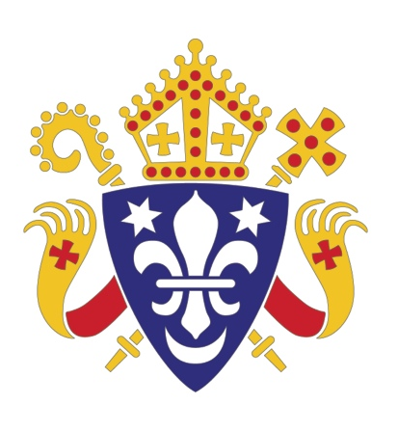
Date as postmark
CATHOLIC BISHOPS’ CONFERENCE
FROM: BISHOP KIERAN CONRY
CHAIR, DEPT. FOR EVANGELISATION AND CATECHESIS
HOME MISSION SUNDAY, 15 SEPTEMBER 2013

Dear Father,
I would be most grateful for your support in promoting and celebrating Home Mission Sunday 2013. The theme of this year’s Sunday is ‘Crossing the Threshold: Ministry and Outreach to Non-Churchgoing (lapsed) Catholics’. It has been chosen in response to requests from all tiers of the Catholic community in England and Wales for this to be a significant focus of the work of evangelisation.
It is estimated that while there are around one million churchgoing Catholics in England and Wales, there are at least four million who rarely or never visit their local parish. In response to this reality the Bishops’ Conference Department for Evangelisation and Catechesis is inviting every parish to make ministry and outreach to non-churchgoing Catholics a priority in the year ahead, beginning on 15 September 2013 – Home Mission Sunday.
While the lapsation of the baptised is not new within the Catholic community, the worry and anxiety experienced by parents, siblings and grandparents of non-churchgoing baptised, is deep and heartfelt. We all hold in our hearts at least one person in our family who seems disconnected from the life of the Church. On Home Mission Sunday, let’s remember them in a very special way in our prayers, and also bring before the Lord the wider work of evangelisation in our countries.
The Bishops of England and Wales ask that parishes kindly offer and support a second collection on 15 September, which will fund the development of this area of ministry and outreach. The collection also enables the Bishops to pursue additional projects in support of Home Mission.
You will find in this package:
- Home Mission Sunday leaflets for distribution on 15 September please
- A sample ‘Catholic and Lost Touch’ leaflet designed to be given to non-churchgoing Catholics. Please contact our Home Mission Desk if you’d like to order more.
- A suggested newsletter insert and liturgical materials sheet
- A second collection form to be returned to the office of the Catholic Trust of England and Wales please.

Additional resources and information are available at: www.catholicnews.org.uk/hms13
Thank you in advance for your prayers and support.

God bless you,
Bishop Kieran Conry,
Chair, Bishops’ Conference Department for Evangelisation and Catechesis

