Lutheran-Catholic
Common Commemoration
of the Reformation in 2017
Common Prayer
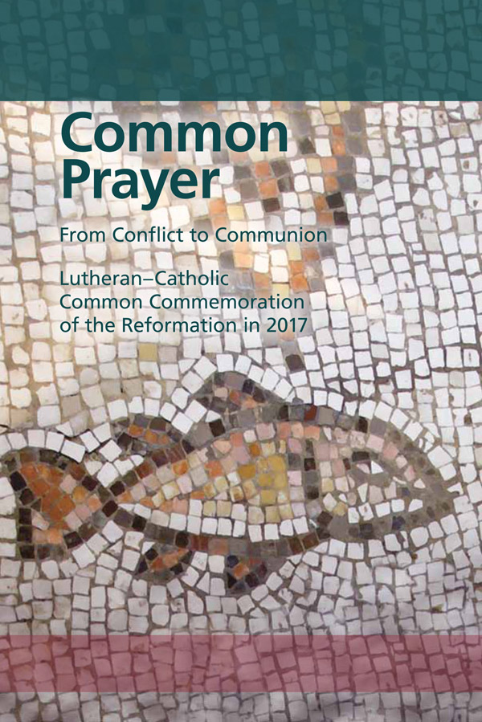
Sunday 26th March 2017 at 3pm
St George’s Cathedral
WELCOME
Canon Richard Hearn, Dean of St George's Cathedral, and the Revd Torbjørn Holt, Chairman of the Council of Lutheran Churches.
HYMN: Holy God, we praise your name
Holy God, we praise your name;
Lord of all, we bow before you.
All on earth your sceptre claim,
All in heaven above adore you.
Infinite your vast domain,
Everlasting is your reign.
Hark! The glad celestial hymn
Angel choirs above are raising;
Cherubim and seraphim,
In unceasing chorus praising,
Fill the heavens with sweet accord:
"Holy, holy, holy Lord!"
Lo, the apostolic train
Join your sacred name to hallow;
Prophets swell the glad refrain,
And the white robed martyrs follow;
And from morn to set of sun
Through the Church the song goes on.
You are King of Glory, Christ;
Son of God, yet born of Mary.
For us sinners sacrificed,
As to death a Tributary,
First to break the bars of death,
You have opened heaven to faith.
Holy Father, holy Son,
Holy Spirit, three we name you,
Though in essence only one;
Undivided God we claim you
And, adoring, bend the knee
While we own the mystery.
GREETING
The Most Revd Peter Smith, Archbishop of Southwark

In the name of the Father, and of the (+) Son, and of the Holy Spirit.
Amen.
Peace be with you.
And with your spirit
(Archbishop Peter gives a word of welcome.)

The Rt Revd Dr Martin Lind, Bishop of the Lutheran Church in Great Britain

Dear sisters and brothers in Christ, welcome to this ecumenical prayer, which commemorates the 500 years of the Reformation. For over 50 years Lutherans and Catholics have been on a journey from conflict to communion. With joy, we have come to recognise that what unites us is far greater than what divides us. On this journey, mutual understanding and trust have grown.

The Most Revd Bernard Longley, Archbishop of Birmingham
So it is possible for us to gather today. We come with different thoughts and feelings: thanksgiving and repentance, joy in the Gospel and sorrow for division. We gather in remembrance, in thanksgiving and confession, and in common witness and commitment.
Bishop Lind

St Paul writes in 1 Corinthians 12: “If one member suffers, all suffer together; if one member is honoured, all rejoice together.” What affects one member of the body also affects all the others. For this reason, when Lutheran Christians remember the events that led to the particular formation of their churches, they do not wish to do so without their Catholic fellow Christians. In remembering with each other the beginning of the Reformation, we are expressing our unity through Baptism.

Archbishop Longley
Let us pray.
[brief silence]

Jesus Christ, Lord of the church, send your Holy Spirit! Illumine our hearts and heal our memories. O Holy Spirit; help us to rejoice in the gifts that have come to the Church through the Reformation, prepare us to repent for the dividing walls that we, and our forebears, have built, and equip us for common witness and service in the world. Amen.

HYMN: A mighty fortress is our God

A mighty fortress is our God,
a sword and shield victorious;
he breaks the cruel oppressor’s rod
and wins salvation glorious.
The old evil foe, sworn to work us woe,
with dread craft and might, he arms himself to fight.
On earth he has no equal.

No strength of ours can match his might!
We would be lost, rejected.
But now a champion comes to fight,
whom God himself elected.
Ask who this may be: Lord of hosts is he!
Christ Jesus our Lord, God’s only Son, adored.
He holds the field victorious.

Though hordes of devils fill the land
all threat'ning to devour us,
we tremble not, unmoved we stand;
they cannot overpow’r us.
This world’s prince may rage, in fierce war engage.
He is doomed to fail; God’s judgement must prevail!
One little word subdues him.

God’s Word forever shall abide,
no thanks to foes, who fear it;
for God himself fights by our side
with weapons of the Spirit.
If they take our house, goods, fame, child or spouse,
wrench our life away, they cannot win the day.
The kingdom’s ours forever!

THANKSGIVING

Reading from ‘From Conflict to Communion’*:
“Lutherans are thankful in their hearts for what Luther and the other reformers made accessible to them: the understanding of the gospel of Jesus Christ and faith in him; the insight into the mystery of the Triune God who gives himself to us human beings out of grace and who can be received only in full trust in the divine promise; the freedom and certainty that the gospel creates; in the love that comes from and is awakened by faith, and in the hope in life and death that faith brings with it; and in the living contact with the Holy Scripture, the catechisms, and hymns that draw faith into life” (#225). “Lutherans want to share this gift with all other Christians.” (#226).

Reading from ‘From Conflict to Communion’*:
“Catholics and Lutherans have so much of the faith in common that they can
… be thankful together.” (#226). Encouraged by the Second Vatican Council, Catholics “gladly acknowledge and esteem the truly Christian endowments from our common heritage which are to be found among our separated brethren. It is right and salutary to recognise the riches of Christ and virtuous works in the lives of others who are bearing witness to Christ, sometimes even to the shedding of their blood. For God is always wonderful in His works and worthy of all praise.” (Unitatis Redintegratio, Chapter 1). In this spirit, Catholics and Lutherans embrace each other as sisters and brothers in the Lord. Together they rejoice in the truly Christian gifts that they both have received and rediscovered in various ways through the renewal and impulses of the Reformation. These gifts are reason for thanksgiving.

Archbishop Longley
Let us pray. [brief silence]

Thanks be to you, O God, for the many guiding theological and spiritual insights we have all received through the Reformation. Thanks be to you for the good transformations and reforms that were set in motion by the Reformation or by struggling with its challenges. Thanks be to you for the proclamation of the Gospel that occurred during the Reformation and that since then has strengthened countless people to live lives of faith in Jesus Christ. Amen.

Song of Thanksgiving:

Laudate Dominum, Laudate Dominum, omnes gentes, jubilate

REPENTANCE

Bishop Lind

“In the sixteenth century, Catholics and Lutherans frequently not only misunderstood but also exaggerated and caricatured their opponents in order to make them look ridiculous. They repeatedly violated the eighth commandment, which prohibits bearing false witness against one’s neighbour.” (#233). Lutherans and Catholics often focused on what separated them from each other rather than looking for what united them. They accepted that the Gospel was mixed with political and economic interests of those in power. Their failures resulted in the deaths of hundreds of thousands of people. We deeply repent of the evil things that Catholics and Lutherans have mutually done to each other.

Archbishop Longley

Let us pray.
[brief silence]

O God of mercy, we lament that even good actions of reform and renewal could have destructive consequences.

Kyrie eleison (sung)

Bishop Lind

We bring before you the burdens of the guilt of the past when our forebears did not follow your will that all be one in the truth of the Gospel.

Christe eleison

Archbishop Longley

We confess our own ways of thinking and acting that perpetuate the divisions of the past. As communities and as individuals, we build many walls around us: mental, spiritual, physical, political walls that result in discrimination and violence. Forgive us, Lord.

Kyrie eleison

Bishop Lind

Christ is the way, the truth and the life. He is our peace, who breaks down the walls that divide, who gives us, through the Holy Spirit, ever-new beginnings.
Archbishop Longley

In Christ, we receive forgiveness and reconciliation and we are strengthened for a faithful and common witness in our times.
Amen.

THE PEACE
Bishop Lind

Let the peace of Christ rule in your hearts, since as members of one body you are called to peace.
The peace of Christ be with you always.
And with your spirit.
Let us offer each other a sign of reconciliation and peace.
The people may greet one another with a sign of Christ’s peace and say,' Peace be with you'.
SONG: Make me a channel of your peace
Make me a channel of your peace
Where there is hatred let me bring your love
Where there is injury, your pardon Lord
And where there’s doubt true faith in You
Make me a channel of your peace
Where there’s despair in life let me bring hope
Where there is darkness only light
And where there's sadness ever joy
Oh, Master grant that I may never seek
So much to be consoled as to console
To be understood as to understand
To be loved as to love with all my soul

Make me a channel of your peace
It is in pardoning that we are pardoned
In giving to all that we receive
And in dying that we’re born to eternal life

COMMON WITNESS AND COMMITMENT
As we continue our journey from conflict to communion, let us hear the Gospel according to John:

I am the true vine, and my Father is the vine grower. He removes every branch in me that bears no fruit. Every branch that bears fruit he prunes to make it bear more fruit. You have already been cleansed by the word that I have spoken to you. Abide in me as I abide in you. Just as the branch cannot bear fruit by itself unless it abides in the vine, neither can you unless you abide in me. I am the vine, you are the branches. Those who abide in me and I in them bear much fruit, because apart from me you can do nothing. (John 15:1-5).
The Gospel of the Lord.
Praise to you, O Christ.
JOINT SERMON
Archbishop Longley and Bishop Lind
CONFESSION OF FAITH
Archbishop Longley
Together let us confess our faith.
The Apostles' Creed
I believe in God, the Father Almighty, Creator of heaven and earth; and in Jesus Christ, His only Son, our Lord: Who was conceived by the Holy Spirit, born of the Virgin Mary; suffered under Pontius Pilate, was crucified, died and was buried. He descended into hell; the third day He rose again from the dead; He ascended into heaven, is seated at the right hand of God the Father Almighty; from thence He shall come to judge the living and the dead. I believe in the Holy Spirit, the Holy Catholic Church, the communion of Saints, the forgiveness of sins, the resurrection of the body, and life everlasting. Amen.
COMMITMENTS: FIVE IMPERATIVES
Representatives of each tradition will light candles after each commitment is read.
Archbishop Longley: Our ecumenical journey continues. In this worship, we commit ourselves to grow in communion. The five imperatives found in From Conflict to Communion will guide us.
Our first commitment: Catholics and Lutherans should always begin from the perspective of unity and not from the point of view of division in order to strengthen what is held in common even though the differences are more easily seen and experienced. (#239)
A candle is lit as all sing:
Christ, be our light! Shine in our hearts.
Shine through the darkness.
Christ, be our light!
Shine in your church gathered today.

Bishop Lind: Our second commitment: Lutherans and Catholics must let themselves continuously be transformed by the encounter with the other and by the mutual witness of faith. (#240)
A candle is lit as all sing:
Christ, be our light! Shine in our hearts…

Archbishop Longley: Our third commitment: Catholics and Lutherans should again commit themselves to seek visible unity, to elaborate together what this means in concrete steps, and to strive repeatedly towards this goal. (#241).
A candle is lit as all sing:
Christ, be our light! Shine in our hearts…

Bishop Lind: Our fourth commitment: Lutherans and Catholics should jointly rediscover the power of the gospel of Jesus Christ for our time. (#242)
A candle is lit as all sing:
Christ, be our light! Shine in our hearts…

Archbishop Longley: Our fifth commitment: Catholics and Lutherans should witness together to the mercy of God in proclamation and service to the world (#243)
A candle is lit as all sing:
Christ, be our light! Shine in our hearts.
Shine through the darkness.
Christ, be our light!
Shine in your church gathered today.

INTERCESSORY PRAYER
From ‘From Conflict to Communion’*:

Ecumenical engagement for the unity of the church does not serve only the church but also the world so that the world may believe.” (#243). Let us now pray for the world, the church and all those in need….
God of mercy, throughout history your goodness prevails. Open the hearts of all people to find you and your mercy that endures forever.
O, loving Father, hear us we pray (sung)
God of peace, bend that which is inflexible, pull down the barriers that divide, break the attachments that thwart reconciliation. Bring peace in this world, especially in …. Restore wholeness among us and show us your mercy.
O, loving Father, hear us we pray
God, rock and fortress, protect refugees, those without homes or security, all the abandoned children. Help us always to defend human dignity. Show us your mercy!
O, loving Father, hear us we pray
God, creator, all creation groans in expectation. Convert us from exploitation and teach us to live in harmony with your creation. Show us your mercy!
O, loving Father, hear us we pray
God of mercy, strengthen and protect those who are persecuted for faith in you, and those of other faiths and no faith who suffer persecution. Give us the courage to profess our faith. Show us your mercy!
O, loving Father, hear us we pray
God of love, your Son Jesus reveals the mystery of love among us. Strengthen that unity that you alone sustain in our diversity. Show us your mercy!
O, loving Father, hear us we pray
God our sustenance, bring us together at your Eucharistic table, nurture within us and among us a communion rooted in your love. Show us your mercy!
O, loving Father, hear us we pray
In confidence that you, O God, hear our prayers for the needs of the world and for the unity of all Christians in their witness, let us pray as Jesus taught us, in our own language….
The Lord’s Prayer
BLESSING
Archbishop Smith
For all that God can do within us, for all that God can do without us.
Thanks be to God.
For all in whom Christ lived before us, for all in whom Christ lives beside us.
Thanks be to God.
For all the Spirit wants to bring us, for where the Spirit wants to send us.
Thanks be to God.
The blessing of God, Father, Son and Holy Spirit (+), be with you and accompany you on your joint journey, now and forever.
Amen.

CLOSING HYMN: O, God of vision
O God of vision far greater than all human scheming,
Gather us now in your presence, refreshing, redeeming.
Show us anew—Life in your breath-taking view,
Lovely beyond all our dreaming.
Pour out Your Spirit on all now assembled before You.
May our diversity here be a means to adore You.
Women and men—Young, old and youthful again,
Make us as one, we implore You.
Grant to us insight, O God, for this time of decision.
May we dream challenging dreams of both depth and precision.
Speak through the dark—Dispel by lightning’s bright spark
Whatever clouds dim our vision.
Break the sun’s rays into colour, a rainbow around us.
Storm clouds, though real and near, are not enough to confound us.
Arched in the sky—Beauty and promise are high,
Giving us hope to astound us.
Organ voluntary – God is our Refuge – Frederick Stocken

There is an opportunity to contribute to a retiring collection for
the work of the Cathedral in support of the local foodbank
as you leave the building.

*'From Conflict to Communion: Lutheran-Catholic Common Commemoration of the Reformation in 2017 - Report of the Lutheran-Roman Catholic Commission on Unity'. ©2013 by Evangelische Verlagsanstalt GmbH · Leipzig and Bonifatius GmbH Druck – Buch – Verlag Paderborn

The Cathedral is licensed by Calamus and C.C.L.

The organisers of the service are grateful to the Dean and staff of
St George’s Cathedral for their hospitality and support.

____________________________________

The Most Revd Peter Smith, Archbishop of Southwark
The Most Revd Bernard Longley, Archbishop of Birmingham
The Rt Revd Dr Martin Lind, Bishop of the Lutheran Church in Great Britain
The Revd Canon Richard Hearn, Dean of St George’s Cathedral
The Revd Torbjørn Holt, Chair of the Council of Lutheran Churches
The Revd Canon John O’Toole, National Ecumenical Officer and Secretary,
Department for Dialogue and Unity, Catholic Bishops’ Conference in England & Wales
The Very Revd Thomas Bruch, Dean of the Lutheran Church in Great Britain
The Revd Susanne Freddin Skovhus, Council of Lutheran Churches & Danish Church
Mr David Lin, Chair of the Lutheran Church in Great Britain
Mr Paul Keen, parishioner of St George’s Cathedral
The Revd Helen Calner, Deacon of Swedish Church, London
Maia Lund Newlyn, Danish Church, London
Chelsea Farrow, St Anne’s Lutheran Church, London
Samuel Kendor Barrie, St George’s Cathedral
Naomi Ramatu Veroline Barrie, St George’s Cathedral
Godfrey Offia, St George’s Cathedral
Mr Frederick Stocken, Organist of St George’s Cathedral
Mrs Inge-Lise Nygaard, Soprano,
Mr Toby Forster, Alto
Mr Joshua Baxter, Tenor
Mr David Jones, Bass

____________________________________

Following the service, all worshippers are invited to
a reception in the Amigo Hall, adjacent to the Cathedral.

Many thanks to the Knights & Ladies of Marshall,
for their help with the serving of the refreshments.

______________________________

