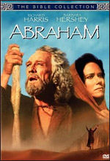
ABRAHAM

1994, Joseph Sargent



In an Italian-US collaboration, a series of movies for television was made featuring key characters of the Old Testament. Later, there were some New Testament additions, especially, The Apocalypse, starring Richard Harris as St John.

By following the series on the Old Testament, the audience can develop a picture of the early centuries of the history of the Hebrew people. While there is a Genesis film, focusing on creation and Noah and the flood, the series begins properly with the drama of Abraham and his choice by God to be the father of his people. Richard Harris is Abraham. While the series tends to present the stories from Genesis as historical fact, the saga nature of this history indicates that it has been remembered in dramatic form rather than literal form. (George C. Scott appeared as Abraham in John Huston's 1966 The Bible... in the Beginning.

The series continues with the story of Joseph (Paul Mercurio) and Moses (Ben Kingsley). Samson deals with the period of the Judges and the era of the kings is seen in David and in Solomon. (There are also films on the prophet Jeremiah and the queen Esther.)

The films serve as a visualising of the biblical stories and a re-creation of their background and atmosphere.

