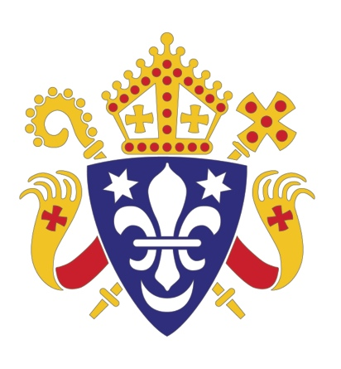
Catholic Bishops’ Conference of England and Wales
HOME MISSION SUNDAY: 21 SEPTEMBER 2014
EVANGELISATION RESEARCH PROJECT
Supporting ministry and outreach to non churchgoing (lapsed) Catholics

Challenges and Opportunities for the New Evangelisation:
A case study of Catholic primary school parents in England and Wales

Comissioned by: Bishop Kieran Conry, Chair of the Department for Evangelisation
and Catechesis
Researcher: Dr Ann Casson
Projector Coordinator: Clare Ward, Home Mission Desk

Executive Summary

This research paper was commissioned to inform and become an integral part of the Bishops’ Crossing the Threshold initiative. It includes input from members of the national core group for ministry and outreach to non churchgoing Catholics; this group is an instrument of the Department for Evangelisation and Catechesis which is chaired by Bishop Kieran Conry. The focus of this study is, therefore, Catholics who do not regularly attend Sunday Mass in England and Wales.

Many baptised Catholics do not regularly attend Mass; however, they are involved in Catholic education, social action, and youth work. This case study focussed on Catholic education, in particular, on young Catholic parents of children in Catholic primary schools in England and Wales.

The study explored:
- The Catholicity of Catholic parents
- It investigated the existing connections that they value with the Catholic Church
- Considered how the Catholic Church could strengthen its relationship with the parents, in encouraging the sharing of the gifts and talents that they bring to the Body of Christ.

The chosen research method was a qualitative case study, a method that generates rich data to complement and illuminate the narrative behind statistics. This involved in-depth semi-structured interviews, and a self-completed survey of parents at Catholic primary schools.

This research study aims to assist the work of the New Evangelisation. The report produced reflects on the implications for the future shaping of practice, with regards to pastoral ministry and outreach to non churchgoing Catholics. It aims to serve and benefit those who will discern new pathways for the furthering of Catholic evangelisation in England and Wales.
Some of the question areas:
- How do Catholic parents in England and Wales currently express their Catholic Faith?
- Why do these Catholic parents seek a Catholic primary school education for their children?
- Why do many Catholic primary school parents not attend weekly Sunday Mass?
- In what ways would these Catholic parents wish to grow in faith and re-connect with parish life?

This research paper will be published to coincide with Home Mission Sunday 2014.
Home Mission Sunday is resourced by the Bishops’ Conference Home Mission Desk in service of the Department for Evangelisation and Catechesis. Email: homemission@cbcew.org.uk www.catholicnews.org.uk
Catholic Trust for England and Wales, 39 Eccleston Square, London, SW1V 1BX.
A company limited by guarantee and registered in England and Wales. Company No. 4734592 Registered Charity No. 1097482.

Alpha for Catholics, Archdiocese of Southwark, Caritas Social Action Network (CSAN), Catholic Evangelisation Services (CaFE), Department for Evangelisation and Catechesis, (Catholic Bishops’ Conference of England and Wales), Diocese of Hexham and Newcastle, Diocese of Nottingham, Diocese of Portsmouth, Home Mission Desk, (Catholic Bishops’ Conference of England and Wales), Keeping in Touch (KIT), Landings UK, Maryvale Institute, National Board of Catholic Women (NBCW), RCIA Network.

