CATHOLIC BISHOPS’ CONFERENCE OF ENGLAND AND WALES
Committee for Catholic Jewish Relations

Holocaust Memorial Day
27th January 2015

70 years after the liberation of Auschwitz
50 years after Vatican II’s ‘Nostra Aetate’
20 years after the Serbian Genocide

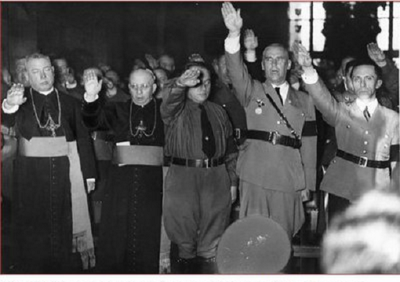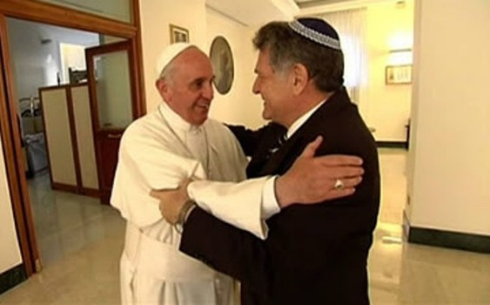

Keep the Memory Alive

Auschwitz, a Nazi death camp, was liberated by Russian troops on 27th January 1945. They found 7,500 prisoners and about 600 corpses there, left behind when the Nazis evacuated the camp. 370,000 men’s suits, 837,000 items of women’s clothing and 7.7 tonnes of human hair also gave testimony to the systemic programme of genocide that had been carried out there. Some 1.1 million people, the vast majority of them Jews, were murdered by the Nazis at Auschwitz. Some Catholics who are now saints were killed there, too, most notably, Maximilian Kolbe and Edith Stein, along with her sister, Rosa.

Nostra Aetate is a groundbreaking document of the Second Vatican Council. It radically changed what the Catholic Church teaches about Jews and Judaism. As a result, the Church readily acknowledges that the Jewish people remain very dear to God. It also teaches that Jews are not to be held responsible for the death of Jesus and that the Catholic Church “deplores all hatreds, persecutions and displays of anti-Semitism levelled at any time or from any source against the Jews”. Nostra Aetate became official Church teaching on 28th October, 1965.

The Bosnian Genocide took place from 1992 to 1995 when Serbs sought to cleanse ethnically Bosnia-Herzegovina of all non-Serbs. Serbian forces systematically killed 100,000 Bosniaks and Croats. The most infamous massacre took place at Srebenica when 7,000 Bosniak men were murdered on the orders of Serb General Ratko Mladic. It was the largest single act of genocide in Europe since the end of World War II. It is a poignant reminder that it really is important to ‘Keep the Memory Alive’ in preaching and prayer on the Sunday before National Holocaust Memorial Day, 2015.

Homily for Sunday 25th January 2015
The Gospel of the 3rd Sunday in Ordinary Time calls on us to “repent and believe the good news”. Why not use this text to develop a homily about Holocaust Memorial Day?
You might:
- Revisit Nostra Aetate as you prepare your homily;
- Talk about the change in approach to Jews by the Catholic Church during the last 50 years. It is an example of a change of heart and attitude, bringing about good news;
- Make reference to the Srebenica genocide of 1992-1995. It shows that genocide is still a real issue;
- Talk about the importance of keeping the memory of the Shoah alive lest, in forgetting, we prepare the ground for anti-Semitism and other hatreds to flourish;
- Finish your homily by highlighting the need to review our attitudes frequently, acknowledge our prejudices and have the change of heart that will cleanse us of sin and empower us to follow Jesus more faithfully.
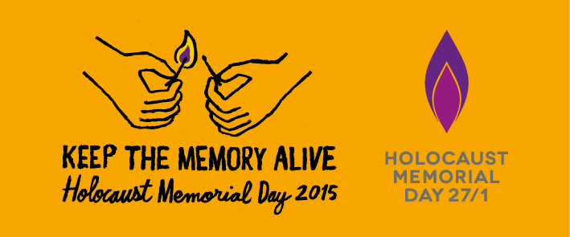
General Intercessions
Let us pray for the Jewish people, to whom the Lord our God spoke first … that God may grant them to advance in love of His Name and faithfulness to his Covenant.
Let us pray for our unique and special relationship with the Jewish people … may Christians everywhere commit themselves to genuine friendship with the People of the Covenant.
Let us pray for an end to genocide and for the purification of our hearts from prejudice and hatred of any kind … may we keep the memory of the past alive so that the future may be free from such evil.
Resources
Vatican Documents on Catholic-Jewish Relations; Guidelines for Catholic Jewish Relations
Catholic Bishops’ Conference of England & Wales: www.catholic-ew.org.uk
International Council of Christians and Jews: www.jcrelations.net
CTS Bookshops: www.ctsbooks.org

For Holocaust Memorial Day Pack, resource materials and assistance
The Holocaust Memorial Day Trust
PO Box 61074, London SE1 5BX
020 7785 7029; enquiries@hmd.org.uk; www.hmd.org.uk

For outreach to schools, resource materials and visits to Auschwitz
Holocaust Educational Trust
BCM Box 7892, London WC1N 3XX
020 7222 6822; info@het.org.uk; www.het.org.uk

For educational material and visits
Beth Shalom Holocaust Centre
Laxton, Newark-on-Trent, NG22 OPA
01623 836627; www.bethshalom.com

The Imperial War Museum
Lambeth Road, London SE1 6HZ
020 7416 5320; www.iwm.org.uk

For general information
The Council of Christians and Jews
Godliman House, 21 Godliman Street, London EC4V 5BD
020 7015 5160; www.ccj.org.uk

For specialist library, advice and courses
Sion Centre for Dialogue and Encounter
34 Chepstow Villas, London W11 2QZ
020 7313 8286; sioncde@yahoo.co.uk; www.sistersofourladyofsion.org

For resources on racial justice and ethnic minorities
Catholic Association for Racial Justice
9 Henry Road, London N4 2LH
020 8802 8080; info@carj.org.uk; www.carj.org.uk

Prepared by the Committee for Catholic Jewish Relations, Catholic Bishops’ Conference of England and Wales. Secretary: Sr Margaret Shepherd nds, 39 Eccleston Square, London SW1V 1BX. 0207901 4855; margaret.shepherd@cbcew.org.uk

