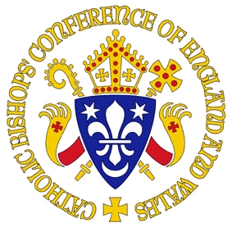

Committee for Marriage and Family Life
Bishops’ Conference for England and Wales

Bursaries Available – Applications Invited
International Conference on the Domestic Church

Leuven, 10-13 March 2010

The Bishops’ Conference Committee for Marriage and Family Life has ten bursaries available to subsidise participation from England and Wales at an international conference entitled: The Household of God and Local Households: Revisiting the Domestic Church which will take place at the Catholic University of Leuven, 10-13 March 2010.

These bursaries are to be divided equally between diocesan marriage and family ministry coordinators, theologians, students of theology, students on the Celebrating Family Leadership programme and those in positions of influence in the Catholic Church in England and Wales. Bursaries amount to £300 and will cover registration fees (including conference dinner) plus £205 towards the cost of travel and accommodation.

Successful applicants must arrange their own travel and accommodation and commit to providing by 30 April 2010, a publishable summary of key learning and/or realistic proposals for future practical action within the Church in England and Wales to extend awareness of and support for the domestic church. Completion of two brief evaluation forms will also be expected: one immediately after the conference and one in March 2011.

Applications are invited in the form of a brief curriculum vitae accompanied by a statement of 500 (min) -750 (max) words describing how the conference is expected to benefit both the professional development of the applicant and their ministry/mission within the Church in England and Wales. Links to further information about the conference including programme and details of travel and accommodation possibilities are included below.

Closing date: 8 February 2010.

Please address applications to Rt Rev John Hine, Chair, Bishops’ Committee for Marriage and Family Life. c/o Elizabeth Davies, Marriage and Family Life Project Officer, Catholic Bishops’ Conference of England and Wales, 39 Eccleston Square, London SW1V 1BX Email: elizabeth.davies@cbcew.org.uk. Tel: 07817479694

Conference programme: http://www.intams.org/events-col10.htm
Travel and accommodation: http://www.intams.org/events-col10-travelaccom.htm

