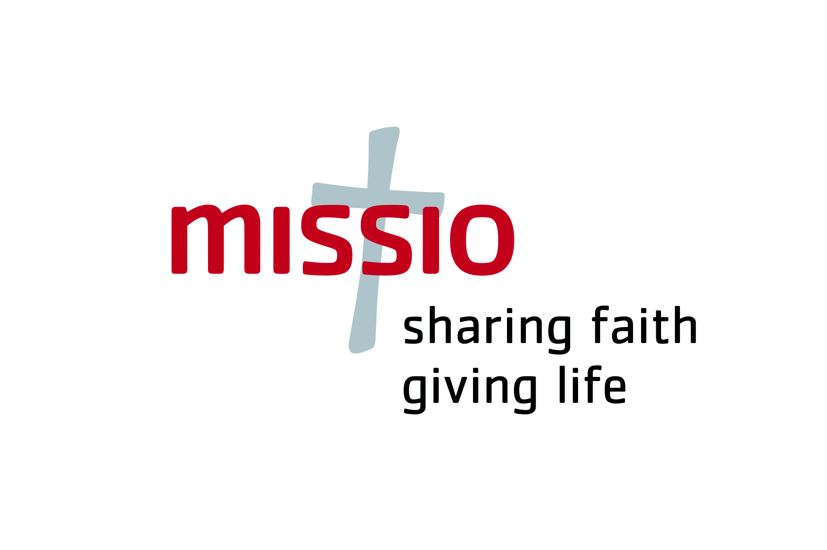

You have shared your Faith and have given life

How about some good news for a change?
The money collected in England and Wales as a result of World Mission Sunday 2008 plus the APF (Association for the Propagation of the Faith) Red Box collections in more than 200,000 homes across the two countries was all distributed during the week of 24-28 September.
In spite of the many hardships people are experiencing as a result of the current economic situation, the Catholics of England and Wales contributed a massive £2,450,184.05 to dioceses in mission countries across the world, sharing their faith and giving life to those in need.

Every country in the world contributes to the APF. This year, England and Wales take responsibility for the support of Ghana, Zimbabwe, South Africa, India and Pakistan. As you will see, the money you so kindly donated to the support of a young or struggling Church is given directly to the country’s Nuncio, who takes personal responsibility for its reaching the bishops who have asked for your support.

The table below shows the total sums sent to each country. Virtually every bishop has requested a portion of his funding in order to train and support the catechists who are such a vital part of every mission life and without whom, the diocese could not function, especially in remote areas which might only see a priest a couple of times in the course of a single year.

Other funding is allocated according to specific needs. In the poor, remote, rural area of the diocese of Dibrugarh in India, for example, Bishop Aind is doing tremendous work in training the lay people to play an active part in evangelisation in the 32 parishes of the diocese, arranging spiritual Retreats for their refreshment, education and renewal. Many other bishops in both India and Africa have chosen to concentrate on building churches in new parishes. Often the people themselves will make the bricks, but they cannot afford cement, roofing materials etc.

Part of the funding given to Cardinal Napier in the Archdiocese of Durban, South Africa, will be used to translate the Bible into Zulu, enabling people to read the Scriptures in their own language.

Truly, the word ‘thank you’ does not say it all. Without your help, many mission dioceses could not function.

The sums disbursed during the week of 24-28 September 2009 all include the ‘ordinary subsidy’ of £21,400(approx) towards the running expenses of the diocese.
Allocations are all made in USD, which are here converted into GBP.

Missio APF funding allocations 2009
 | Allocation £ |  | Allocation £
AFRICA |  | INDIA
Ghana | 491,487.88 | India | 997,015.42
Accra: Archbishop C G Palmer-Buckle | 72,198.54 | Dibrugarh: Bishop Joseph Aind | 28,575.24
Cape Coast: Archbishop Cardinal Peter KA Turkson | 99,408.91 | Hyderabad: Archbishop Joji | 81,630.79
Damongo: awaiting the Pope’s appointment of a bishop | 70,712.09 | Jalpaiguri: Bishop Tirkey | 33,394.41
Donkorkrom: Apostolic Administrator | 98,348.84 | Jammu-Srinagar: Bishop Peter Celestine Elampassery | 123,982.22
Goaso: Bishop Peter Kwaku Atuahene | 65,516.41 | Jamshedpur: Bishop Felix Toppo SJ | 68,805.29
Ho: Bishop Francis AK Lodonu | 85,357.86 | Jashpur: awaiting the Pope’s appointment of a bishop | 53,153.66
Total from England and Wales | 491,487.88 | Jabhua: Bishop John Ganawa Deprasad SVD | 59,353.41
South Africa | 404,559.06
Durban: Cardinal Wilfred Napier OFM | 46,933.51 | Kohima: Bishop Jose Mukala | 79,261.54
Kroonstad: Bishop Stephen Brislin | 58,664.34 | Kurnool: Bishop Anthony Poola | 106,726.68
Mariannhill: Bishop Pius M Dlungwana | 24,222.81 | Madurai: Archbishop Peter Fernando | 72,344.49
Oudtshoorn: Bishop Edward R Adams | 41,377.53 | Mangalore: Bishop Aloysius Paul D'Souza | 38,152.07
Pietersburg: Bishop Mogale Paul Nkhumishe | 53,729.03 | Shillong: Archbishop Dominic Jala | 38,152.07
Port Elizabeth: Bishop Michael Coleman | 28,529.66 | Sivagangai: Bishop Jebamalai Susaimanickam | 60,892.66
Pretoria: Archbishop Paul Mandla Khumalo CMM | 67,927.76 | Srikakulam: Bishop Innaya Chinna Adagatla | 63,056.36
Queenstown: Bishop Herbert N Lenhof SAC | 34,580.85 | Tiruchirapalli: Bishop Anthony Devotta | 57,478.22
Rustenburg: Bishop Kevin Dowling | 48,783.70
Total from England and Wales | 404,559.06 | Total from England and Wales | 997,015.42
ZIMBABWE |  | PAKISTAN
Zimbabwe | 450,873.04 | Pakistan | 109,987.59
Bulawayo: Archbishop Alex Thomas Kaliyanil, SVD | 42,402.21 | Faisalabad: Bishop Joseph Coutts | 36,452.15
Chinhoyi: Bishop Dieter Scholz | 43,804.24 | Quetta: Bishop Victor Gnanapragasam, OMI,  Prefect Apostolic | 73,490.47
Gokwe: Bishop Angel Floro Martinez, IEME | 36,674.64 | Total from England and Wales | 109,987.59
Gweru: Bishop Martin Munyanyi | 47,937.88 | ZIMBABWE contd.
Harare: Archbishop Robert Christopher Ndlovu | 52,250.10 | Masvingo: Bishop Michael Dixon Bhasera | 83,647.18
Hwange: Bishop Alberto Serrano, IEME | 51,818.28 | The Episcopal Conference of Zimbabwe:  Fr Conrad Chibango | 18,507.12
Mutare: Bishop Alexio C Muchabaiwa | 73,825.69 | Total from England and Wales | 450,873.04
...AND THE GRAND TOTAL FROM THE CATHOLICS OF ENGLAND AND WALES .... £2,450,184.05

