Mr D Singh

The Commission on Integration and Cohesion
Seventh Floor
Eland House
Bressenden Place
London SW1E 5DU

coic@communities.gsi.gov.uk

26 January 2007

Dear Mr Singh,

I am writing on behalf of the Catholic Bishops’ Conference of England and Wales. The Bishops attach considerable importance to the Commission’s work and we are grateful for this opportunity to respond to your consultation.

Our response highlights the many different groups in our society who, for different reasons, are separated and in some cases alienated from the mainstream. We outline the role the Catholic community has played over 150 years in supporting migrant, ethnic minority and other marginalised groups and helping them to integrate into society. With the current arrival of many new migrants in the UK, the Church here is being called on to play a similar role today.

Finally, we are concerned about relations between faith communities and secular authorities, who too often work with a narrow concept of secular society which would exclude religion from the public arena. We feel that there is an urgent need for a more inclusive concept, and we hope that the Commission will address this question.

I hope that our response, alongside others, will be of some use to your Commission in clarifying the role that churches and faith communities may play in the future.

With kind regards,

Yours sincerely,

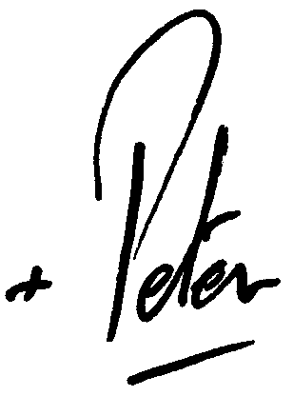

Peter Smith
Archbishop of Cardiff
Chairman of the Department for Christian Responsibility and Citizenship
Catholic Bishops’ Conference of England and Wales

