Reflections

on the
Lectionary for Easter 2009

The Year of Mark

Rt. Rev. Christopher Budd
Bishop of Plymouth
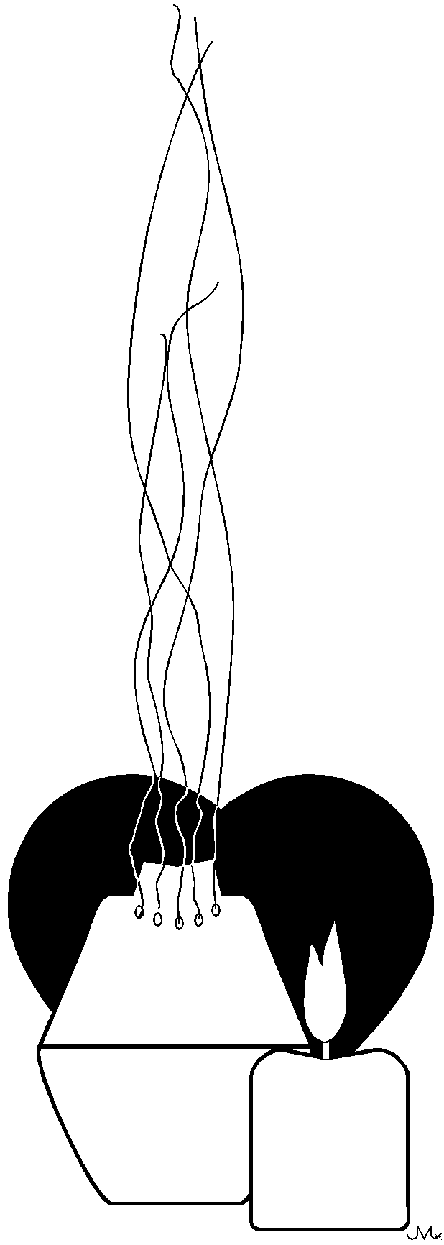
“Christians to the paschal victim offer sacrifice and praise. The sheep are ransomed by the Lamb and Christ the Undefiled adds sinners to his Father reconciled. Death with life contended, combat strangely ended, life’s own champion slain yet lives to reign. Tell us Mary; say what thou didst see upon the way. The tomb the living did enclose, I saw Christ’s glory as he rose. The Angels there attesting, shroud with grave clothes resting. Christ my hope has risen; he goes before you into Galilee. That Christ is truly risen from the dead we know, victorious King thy mercy show. Amen.”

Victimae Paschali Laudes
Sequence from the Mass of Easter Day

Easter sunday

Living in an Easter World
Colossians 3, 1-4

At first reading, this short excerpt could give the impression we are being invited to live in a world different from the one in which we are.

When we are encouraged by the apostle to think the things of heaven and to live in a way that is appropriate for heaven we are not being encouraged to live in a pretend world. What has happened in Christ is that our earthly existence has been colonised by the gift of heaven. That gift will now drive the reality of our earthly life and will enable us to reach a destiny that lies out of and beyond our native powers.

Christ is the heaven that has dwelt among us. Through his death and resurrection he has broken the stranglehold of sin and freed us to be heavenly. Being heavenly is not a recipe for ignoring the things of earth, but an invitation to treat all other humans as brothers and sisters and to treat the whole of Creation in a different manner.
It is interesting that our present concern about our planet and universe can so easily be addressed if we take our Easter Faith seriously. Living simply, for example, is about living as an Easter people.

While thanking the Lord for the gift of Easter, we can pray for the ability to take seriously our Easter Faith.

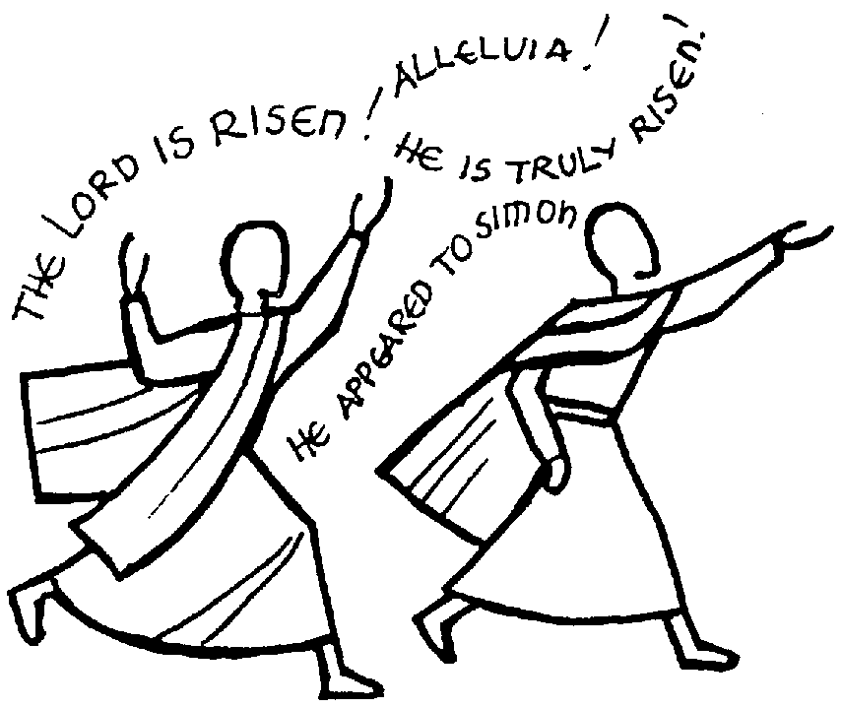

Pray for an Easter Faith
(Acts 10, 34. 37-43; Jn. 20, 1-9)

Second Sunday of Easter

FAITH
1 John 5, 1

This second Sunday of Easter focuses on the centrality of Faith in the disciples’ life. Whether we follow the story of the Apostle Thomas, or listen to the reading of John’s first letter, we are confronted by the necessity of believing in the Son of God, who is Jesus. This is the pivotal and irreplaceable centre of the community’s faith.

Faith is being “begotten by God”, so that we totally belong to God. This belonging is brought about by our faith which enables us to love God, and is especially the result of being begotten and loved by God.

Faith enables us to overcome the world. In John’s writings, the world is always the collection of forces that oppose God’s ways and the only way we can secure victory over them is through faith centred on Jesus.

The witnesses standing on the side of Jesus and giving credence to his status as the Son of God are the Spirit, water and blood. The Spirit at the Jordan with the water and Jesus’ own bloody death show that he is who he claims to be. Their witness is to his identity as Son of God and the reality of his humanity. This witness is still being given through the utterances of the Spirit in the community of the faithful and the sacraments of baptism (water) and the Eucharist (blood).

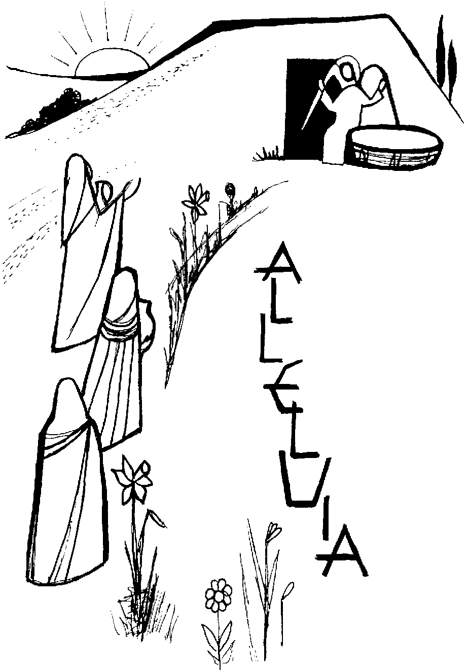
The faith of the community is to give the same witness as Jesus gave during his life, and which becomes the task of the community down the ages. Our faith cannot be anything but witness.

Pray for a faith that will conquer the world
(Acts 4, 32-35; 1 Jn. 20, 19-31)
THIRD Sunday of Easter

Knowing Jesus
1 John 2, 1-5

A part of knowing Jesus is to know ourselves, as people prone to sin, even though the invitation to follow Jesus is an invitation to dwell and walk in the light. Sin is darkness, and if we fall back into sin we have Jesus who can relate to us as an Advocate and as expiation (a sin offering).

Knowing Jesus, though, is not just Christ in the head. Our ideas about Jesus are important as we can get things very wrong if we have the wrong or mistaken ideas.

But knowing Jesus is more than that. It is both having the right understanding and living in a way that will show our ideas are connected with the reality of our lives. John puts it strongly:

“Whoever says I know him, but does not keep his commandments is a liar, and the truth is not in him.”

Sin is about not knowing Jesus and even worse pretending to know him and yet living in a way that conflicts with everything that Jesus stands for.

Again, John puts it strongly and directly:

“But whoever keeps his word, the love of God is truly perfected in him. This is the way we may know that we are in union with him”.


The one who is truly a disciple of Jesus lives in the same way as Jesus – totally to God. If we are trying to do that, we can say without lying, that we know Jesus. The transparency and integrity of our witness needs a life consonant with that of Jesus.

Pray for a truly effective knowledge of Jesus
(Acts 3, 13-15 & 17-19; Luke. 24, 35-48)
Easter Acclamation

1. Did not our hearts burn within us,
Alleluia, Alleluia
as we heard the risen Jesus,
Alleluia.

refrain:
Alleluia, praise the Lord,
praise his word,
Alleluia, praise the risen Lord.

2. Come risen Lord, walk beside us
Alleluia, Alleluia
may your Gospel ever guide us,
Alleluia.

3. Open our hearts, risen Jesus
Alleluia, Alleluia
may your spirit never leave us
Alleluia.
Stephen Dean

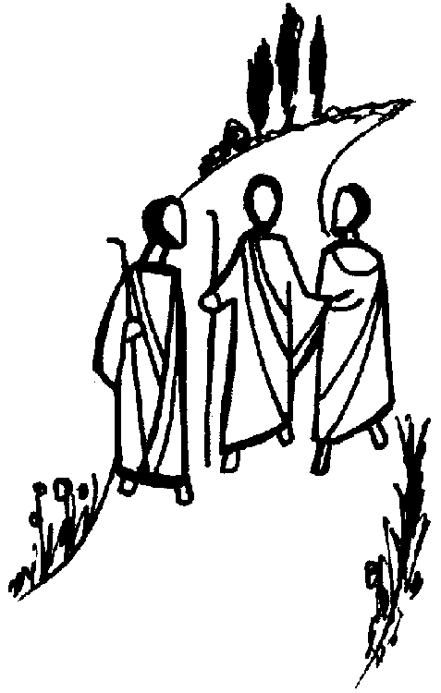
On the road to Emmaus
FOURTH Sunday of Easter

Our Status – God’s Children
1 John 3, 1-2

The effect of God’s love being bestowed upon us is that we become his children. We are his children.

This is a gift and becomes real for us. Our first response is to appreciate the gift. We give thanks - the “thank you factor” so basic in a community which is defined by the Eucharist. We stand back and let ourselves admire the giver of the gift and the reflection of the giver in the one who has received the gift.

We are dealing here with our being in the image and likeness of God, not just as his creation, but as those who have been made members of his household – we belong to the family.

This is not all. We belong to God’s family already, but there is also a future, a destiny for which we are being prepared.

Our text puts it beautifully:
“Beloved, we are God’s children now; what we shall be has not yet been revealed. We do know that when it is revealed we shall be like him, for we shall see him as he is”.

Surely we deal here with heaven and everything that word conjures up!

There is a consoling strand in this. The world does not recognise us as God’s children because the world does not know Him. In times of a rather aggressive atheism and secularism, we are seen as deluded if we wish to believe in God, let alone belong to his family.

Perhaps the challenge to us is not to engage in acrimonious controversy with atheists and secularists, but to live in a way that can make “being God’s children” attractive to human beings without discrimination. Actions speak louder than words!

Pray for the gift of being able to give thanks
(Acts 4, 8-12; Jn. 10, 11-18)

Fifth Sunday of Easter

Having a Good Heart
1 John 3, 18-24

What gives us confidence in the presence of God, if we are not condemned by our heart or conscience? If we have a good heart, we can be in the presence of God and not feel ashamed.
At root our good heart is about having the Spirit within us. It is the Spirit that enables us to be Christian. Christ’s presence to us is spoken about as an ‘indwelling’; and our presence to Christ is in the same mould:

“Those who keep his commandments remain in him, and he in them, and the way we know that he remains in us is from the Spirit that he gave us”.

The death and resurrection of Jesus releases into the world the gift of the Spirit, who comes to dwell within us. It is the Spirit that gives us confidence in the presence of God and enables us to give a twofold witness that we are genuinely Christian:

- The first is our faith in Jesus Christ, the Son of God. Without this we cannot give any authentic witness. Faith here is not a notional, pale, intellectual nod in the direction of Jesus. It is a full-blooded commitment to him;
- If that commitment of faith is present, we can be genuine in our love for each other. This mutual and reciprocal love is only possible if we are fully committed to the Lord. We cannot love each other unless we love the Lord and we must always remember that it is the Lord who loves us first.

The commandment of love expresses in itself all the other more detailed commandments of God.

Pray for a full-blooded commitment to Jesus
(Acts 9, 26-31; Jn. 15, 1-8)
SIXTH Sunday of Easter

God’s Love is primary
1 John 4, 7-12

We really do get down to the foundation of the Christian life. This passage invites us to think and probe deeply about this whole business of love.

Love is such a small word for such a huge reality. Unfortunately in our culture the word love can be given all sorts of different meanings, some of which are the complete opposite of love as revealed by God (sometimes the word can mean me doing my own thing, without any other reference). Love is essentially relational.

When John writes that “God is Love”, he is referring us to the heart of God. Everything we mean by love is there. God is not a remote, isolated, lonesome being, but the infinite being, whose nature is to pour out from him all that is real, all that is alive, lovable and loving.

How do we know this?
Because “God sent his only son into the world so that we might have life through him”. God’s love for us precedes anything that we are or have. God’s love for us brings us into existence and enables us to love in return.

The letter pinpoints the overarching reality and power of love when we read, “Beloved, let us love one another, because love is of God; everyone who loves is begotten by God and knows God”.

If we live a life of genuine love, we belong to God and have that deep and foundational relationship with him. Where there is love, there is God - and vice versa!

If we do not love, we do not belong to God: “Whoever is without love, does not know God for God is Love”.

The Christian life is all about love, because only that will reveal God as He is the source of all life and love.

Pray for the gift of love
(Acts 10, 25-26, 34-35 & 44-48; Jn.15, 9-17)
ASCENSION OF THE LORD

The Cosmic Christ
Ephesians 1, 17-23

This passage is shot through with Thanksgiving. The Spirit of Thanks is a hallmark of the Christian; as a Eucharistic people our overarching task is to give thanks and praise to the Lord.

However woven into this passage of thanks and praise we find some important intercessions, which are worth pondering. Remember the Feast on which this day occurs – The Ascension. The Lord completes his journey back to the Father and his Absolute Victory over everything that sin and death can throw at him. This victory is the work of the Father in Christ, “raising him from the dead and seating him at his right hand in the heavens”.

Christ reigns supreme over everything that is, and our Feast today is about that. The apparent victory of evil on Calvary is precisely that, apparent. Through dying, rising and ascending Christ is in charge: “He put all things beneath his feet and made him as ruler of everything, the head of the Church, which is his body, the fullness of the one who fills all things in every way”.

In acknowledgement of this, we find an intriguing intercession for very specific gifts:
- “A Spirit of wisdom and revelation resulting in knowledge of him (Christ)”
- So that “Eyes of your heart may be enlightened”
- Which results in seeing “What is the hope that belongs to his call”; “What are the riches of glory in his inheritance among the holy ones”; “What is the surpassing greatness of his power for us who believe.”

What are all these gifts about? They are about the person of Christ flowing into every corner of our lives and our Universe. Our whole human reality is transformed into the likeness of Christ, which makes us “other Christs” in the way we live. It is a huge transformation that takes a lifetime of prayer and fidelity.

Pray for fidelity to Jesus
(Acts 1, 1-11; Mk. 16, 15-20)
PENTECOST

Life in the Spirit
Galatians 5, 16-25

As the Lord rises from the tomb and returns to the Father, the final gift of redemption is poured out upon us - the gift of the Spirit. The text from Acts captures the immediate effect of this: those who were divided and separated by sin are brought together in unity. The story of the Tower of Babel is reversed on the day of Pentecost, when the Spirit of Father and Son comes to be with us until the end of time.

As Paul says in his letter to the Christians in Galatia, we are endowed with a huge freedom by the presence of the Spirit. That freedom enables us to live in a certain way, a way that truly reflects the presence of God.

Our freedom is restored by Christ and the gift of the Spirit, so that we can live the good life. We become able to identify and choose that which is good and which reflects the presence of God in our lives. We can recognise the signs of the Spirit’s actions in the life of the Christian. “The fruit of the Spirit is love, joy, peace, patience, kindness, generosity, faithfulness, gentleness and self-control”. A life that is marked by these virtues is a life in the Spirit. What a fruitful text with which to conduct our examination of life!

Paul, with feet on ground, also lists the signs of a life where sin is in control: “immorality, impurity, licentiousness, idolatry, sorcery, hatreds, rivalry, jealousy, fury, selfishness, dissention, factions, envy, drinking bouts, orgies and the like”. Lives marked by these do not belong to the realm of God. If we live like that we are excluded from the Kingdom. We reap the harvest of woe, which is the logical and natural outcome of sin.

Paul lists virtues that are gifts that only the Spirit can give. Freedom is not about doing one’s own thing – a life in which I do what I want. No; it is a life that seeks the good and enshrines it in decisions and the quality of our life.
“Send forth your Spirit, O Lord
and renew the face of the earth”.

Pray for the gift of the Spirit
(Acts 2, 1-11; Jn. 20, 14 - 23)



Bishop’s House
Plymouth

Bishop’s House
Plymouth

