RESPONDING TO THE PSALMS – SEPTEMBER 2026
a project of
the Spirituality Committee of the Bishops’ Conference of England and Wales

We use the Sunday Responsorial Psalm as a focus for prayer and reflection
during the week ahead for yourself or to share with others.
You could note your own thoughts as a possible personal journal.

POPE LEO’s catechesis 12 August 2026
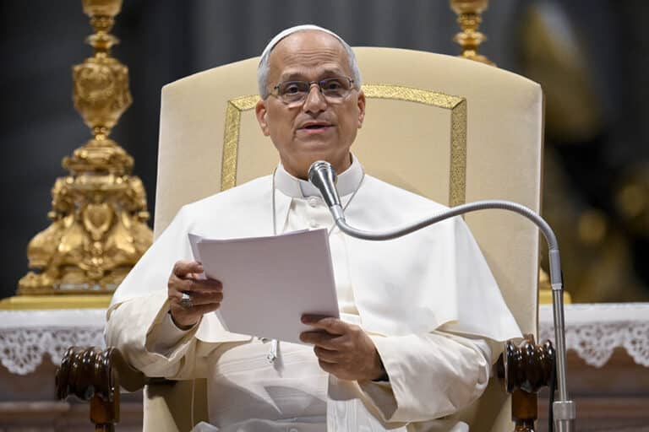
The liturgical year should thus be understood as a constant renewal of
the work of salvation which Christ accomplishes in history. As she
journeys through this temporal cycle, the Church remains in contact
with the Lord’s redemptive action, so that all the faithful may be filled
with His grace
The encounter with Jesus, who died and rose again for us, is the purpose that the Church always pursues, placing the celebration of the Paschal event at the centre of every moment. Hence the Council Fathers considered “the foundation and kernel of the whole liturgical year” to be Sunday, “the original feast day”. In various modern languages, its name indicates that it is the “dies Domini”, “the Lord’s day”. Even in those languages where the reference to the “day of the sun” (Sunday, Sonntag) has prevailed, the link with Christ can be discerned: Christ is the true “sun of righteousness” who enlightens every person! To sanctify Sunday, it is fundamental to celebrate the Eucharist. Listening to the Word and partaking of the Body of Christ entail, according to the Council Fathers, the coming together in unum that is, the joyful gathering of the faithful.
In this assembly, the Christian community makes visible its communion with the Lord and bears witness to its belonging to Christ and its fidelity to the Church. This assembly cannot be substituted by a solely virtual presence, nor can it be reduced to a merely passive gathering. The liturgical assembly is in fact fulfilled through the active participation of brothers and sisters, called together to “thank God who ‘has begotten them again, through the resurrection of Jesus Christ from the dead, unto a living hope’” (1 Peter 1:3)

Sunday 6 September 23rd Sunday in Ordinary Time

Sunday 13 September 24th Sunday in Ordinary Time

Sunday 20 September 25th Sunday in Ordinary Time

Sunday 27 September 26th Sunday in Ordinary Time

Sunday 6 September 2026 23rd Sunday in Ordinary Time

Responsorial Psalm Ps 95(94):1-2. 6-7b. 7c-9. ℟7c, 8a

O that today you would listen to his voice!
‘Harden not your hearts.’

Come, let us ring out our joy to the LORD;
hail the rock who saves us.
Let us come into his presence, giving thanks;
let us hail him with a song of praise.
Holidays over, schools begun, let us renew our joy in having our faith and our Church
Make time to just thank God for allowing us to know, love and serve him

O come; let us bow and bend low.
Let us kneel before the LORD who made us,
for he is our God, and we the people,
the people of his pasture, the flock of his hand.
Reflect how you can happily revere the all-powerful God who relates to us personally
Thank God for the way he cares for all our needs as our shepherd

O that today you would listen to his voice!
‘Harden not your hearts as at Meribah,
as on that day at Massah in the desert
when your forebears put me to the test;
when they tried me, though they saw my work.’
Acknowledge your failings to do God’s will and ask forgiveness
Ask for a greater openness to what God wants of us so that we can fulfil his image within us

Sunday 13 September 2026 24th Sunday in Ordinary Time

Responsorial Psalm Ps 103(102):1-2. 3-4. 9-10. 11-12. ℟8
The LORD is compassionate and gracious,
slow to anger and rich in mercy.

Bless the LORD, O my soul,
and all within me, his holy name.
Bless the LORD, O my soul,
and never forget all his benefits.
Pray the holy name slowly and with devotion
Thank God for all the good people, events and things in your life

It is the Lord who forgives all your sins,
who heals every one of your ills,
who redeems your life from the grave,
who crowns you with mercy and compassion.
Make an examen of conscience to reflect on your life, the good and what needs to change
Thank God for the ways he has forgiven you throughout your life so far

He will not always find fault;
nor persist in his anger for ever.
He does not treat us according to our sins,
nor repay us according to our faults.
Pray for people who put themselves down, who struggle with scruples
Ask God to help you to be forgiving and not judgemental

For as the heavens are high above the earth,
so strong his mercy for those who fear him.
As far as the east is from the west,
so far from us does he remove our transgressions.
As we celebrate the season of creation pray for God’s mercy to bring peace to all people
Since God is forgiving pray for anyone who struggles to forgive, for anyone hard of heart

Sunday 20 September 2026 25th Sunday in Ordinary Time

Responsorial Psalm Ps 145(144):2-3. 8-9. 17-18. ℟18a
The LORD is close to all who call him.

I will bless you day after day,
and praise your name for ever and ever.
The LORD is great and highly to be praised;
his greatness cannot be measured.
Find moments of prayer to remember God throughout your day
Look around at the world in this season of creation and give thanks to the Creator for his wonders

The LORD is kind and full of compassion,
slow to anger, abounding in mercy.
How good is the LORD to all,
compassionate to all his creatures.
Thank God for his kindness and compassion to you, and for people who have been generous to you
Ask for the ability and insight to be compassionate to others in Christ’s name

The LORD is just in all his ways,
and holy in all his deeds.
The LORD is close to all who call him,
who call on him in truth.
Pray for all who have authority over others in any way to exercise it with justice
Pray for all who are oppressed or persecuted for defending the truth
Sunday 27 September 2026. 26th Sunday in Ordinary Time

Responsorial Psalm Ps 25(24):4-5b. 6-7. 8-9. ℟6a
Remember your compassion, O LORD.

O LORD, make me know your ways.
Teach me your paths.
Guide me in your truth, and teach me;
for you are the God of my salvation.
Ask God to help you make right decisions for what you do today
Find a time to stop, to read, to meditate on God’s word to guide you for this week

Remember your compassion, O LORD,
and your merciful love, for they are from of old.
Do not remember the sins of my youth,
nor my transgressions.
In your merciful love remember me,
because of your goodness, O LORD.
Thank God for his mercy and goodness to you despite all your sins and failings
Ask for the ability to show mercy and compassion to people who need that from you

Good and upright is the LORD;
therefore he shows the way to sinners.
He guides the humble in right judgement;
to the humble he teaches his way.
Pray for people who find it difficult to leave sinful or addictive situations
Pray for the gift of humility

