RESPONDING TO THE PSALMS – August 2026
a project of
the Spirituality Committee of the Bishops’ Conference of England and Wales

We use the Sunday Responsorial Psalm as a focus for prayer and reflection
during the week ahead for yourself or to share with others.
You could note your own thoughts as a possible personal journal.

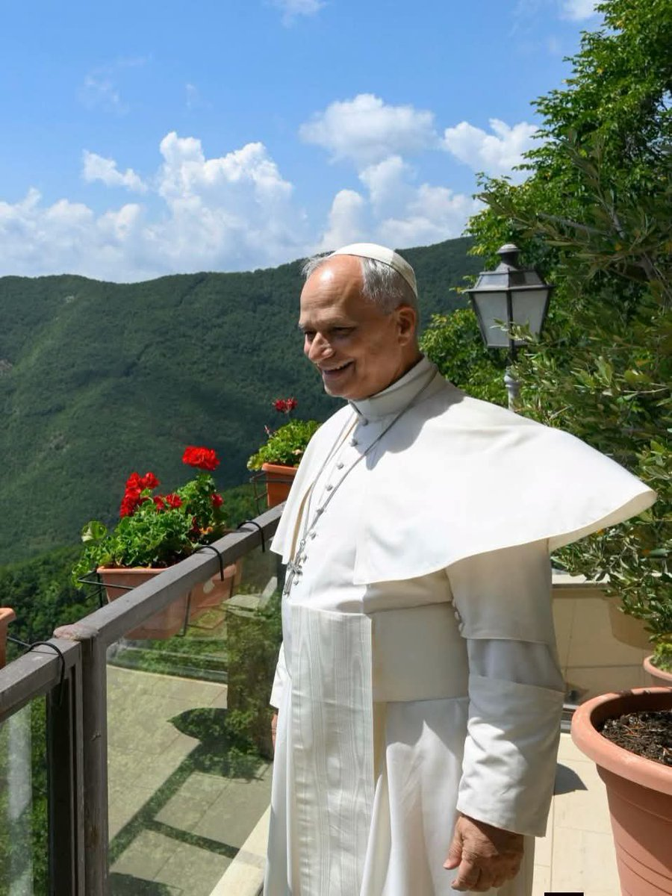
POPE LEO’s writing about holidays says:
We should first remember “those who cannot even enjoy a brief period of rest
because they are crushed by burdens of every kind. Let us think of the sick, of those
who have lost hope in life, of those overwhelmed by the pain of losing loved ones, of
the victims of war, hatred, terrorism, and violence, of those persecuted for their faith
and for justice, of prisoners, of those who have lost their jobs or their homes, and of
migrants who are not welcomed with humanity.” He notes how holidays should be
for everyone a time of respite from work and worries in order to experience genuine
friendship and company, as a foretaste of the communion of the Kingdom of God.
In order to strengthen one’s faith, and calls all Christians to “make use also of the
summer to live out the Gospel of peace and mercy To families, parents and children,
the young and the elderly alike—I wish that this summer may be an opportunity for
fruitful social and religious experiences, and for deepening their mission in the Church
and in society.” He added that he hoped the sick would not lack the closeness of their relatives and volunteers and urged families to not leave their elderly members alone. The Pope encouraged volunteers: “Commit yourselves to bringing humanity and hope to those who suffer, and you will see the fruits of grace. You will discover how much love will fill your lives, how much joy, how much happiness.” Christians should reflect on their privilege and “bear witness to evangelical poverty” when serving the poor, as this is a “service we render to Christ himself. Let us also avoid excess and waste, materialism and consumerism, and let us educate ourselves in simplicity and moderation, the accumulation of wealth hinders evangelization.” He hopes that holidays may be consistent with a Christian way of life.” God's love and grace reach us every day, always. Let us help one another, in every community, not to squander this precious heritage of humanity and peace, the only hope for giving a future to a world threatened by war.”
From July/August 2026 issue of Piazza San Pietro magazine

Sunday 2 August 18th Sunday in Ordinary Time

Sunday 9 August 19th Sunday in Ordinary Time

Sunday 16 August Solemnity of the ASSUMPTION of MARY

Sunday 23 August 21st Sunday in Ordinary Time

Sunday 30 August 22nd Sunday in Ordinary Time

Sunday 2 August 2026 18th Sunday in Ordinary Time

Responsorial Psalm Ps 145(144):8-9. 15-16. 17-18. ℟ cf. 16
YOU OPEN YOUR HAND AND FULFIL US, O LORD.

The LORD is kind and full of compassion,
slow to anger, abounding in mercy.
How good is the LORD to all,
compassionate to all his creatures.
Pray to share some of the kindness and compassion of the Lord with those you meet
Pray for those whose anger and lack of mercy make their lives and those of others a misery

The eyes of all look to you,
and you give them their food in due season.
You open your hand and satisfy
the desire of every living thing.
Prayerfully thank God for all you receive from him that keeps you alive
Pray for those people who provide us the sustenance of our daily living

The LORD is just in all his ways,
and holy in all his deeds.
The LORD is close to all who call him,
who call on him in truth.
Pray that you will be just in all your dealings with people
Pray for truth in a world where fake news challenges honesty and goodness

Sunday 9 August 2026 19th Sunday in Ordinary Time

Responsorial Psalm Ps 85(84):9ab, 10. 11-12. 13-14. ℟8

SHOW US, O LORD, YOUR MERCY,
AND GRANT US YOUR SALVATION.

I will hear what the LORD God speaks;
he speaks of peace for his people and his faithful.
His salvation is near for those who fear him,
and his glory will dwell in our land.
Pray for peace naming the conflicts that are in the news today, especially the ordinary people of those lands
Pray for peace in the communities and families of our own land that God will be glorified

Mercy and faithfulness have met;
justice and peace have kissed.
Faithfulness shall spring from the earth,
and justice look down from heaven.
Pray for all Christians to be faithful to their baptismal covenant, especially ourselves
Pray for all those who are responsible for the justice system in our country to be people of mercy too

The LORD will bestow his bounty,
and our earth shall yield its increase.
Righteousness will march before him,
and guide his steps on the way.
Pray with thanksgiving for the good things you can name in your life and in the lives of those you love
Pray for those who have power in national and local government to be guided to make right decisions

Sunday 16 August 2026 The Assumption of the Blessed Virgin Mary

Responsorial Psalm Ps 45(44):10. 11. 12. 16. ℟10b

ON YOUR RIGHT STANDS THE QUEEN IN GOLD OF OPHIR.

The daughters of kings are those whom you favour.
On your right stands the queen in gold of Ophir.
Pray for all contemplative sisters of our Church to be filled with God’s favour
Pray for all active consecrated women of our Church to be faithful to their calling

Listen, O daughter; pay heed and give ear:
forget your own people and your father’s house.
Pray for lay women who exercise ministry and authority in our Church to be open to God’s word
Pray a blessing on all mothers and those provide a mother’s care for others

So will the king desire your beauty.
He is your lord, pay homage to him.
Pray that all Christians can show God’s beauty by the goodness of their lives
Pray for all who do not know God to open their hearts to him and pay homage to him

They are escorted amid gladness and joy;
they pass within the palace of the king.
Pray for all who have died, remembering those we can name, to enter the gladness and joy of heaven
Pray for ourselves to live lives worthy of Christ that we may one day pass into the palace of his kingdom

Sunday 23 August 2026 21st Sunday in Ordinary Time

Responsorial Psalm Ps 138(137):1-2a. 2bc, 3. 6, 8bc. ℟8bc

O LORD, YOUR MERCIFUL LOVE IS ETERNAL;
DISCARD NOT THE WORK OF YOUR HANDS.

I thank you, LORD, with all my heart;
you have heard the words of my mouth.
In the presence of the angels I praise you.
I bow down towards your holy Temple.
Pray to share some of the kindness and compassion of the Lord with those you meet today
Pray for those whose anger and lack of mercy make their lives and those of others a misery

I give thanks to your name
for your merciful love and your faithfulness.
On the day I called, you answered me;
you increased the strength of my soul.
Thank God for specific moments when he has been loving and faithful to you
Pray for what will strengthen your faith in these days

The LORD is high, yet he looks on the lowly,
and the haughty he knows from afar.
O LORD, your merciful love is eternal;
discard not the work of your hands.
Pray for the marginalised and oppressed in our society to know their true worth
Thank God for his love to you and his continuing presence in your life

Sunday 30 August 2026 22nd Sunday in Ordinary Time

Responsorial Psalm Ps 63(62):2. 3-4. 5-6. 8-9. ℟2b

FOR YOU MY SOUL IS THIRSTING, O LORD, MY GOD.

O God, you are my God; at dawn I seek you;
for you my soul is thirsting.
For you my flesh is pining,
like a dry, weary land without water.
Even if you’re not a morning person make an effort pray as early as you, the first thing of your day
Pray for all who are affected by drought and the lack of water, for the land, for animals and birds

I have come before you in the sanctuary,
to behold your strength and your glory.
Your loving mercy is better than life;
my lips will speak your praise.
Find some time in whatever you call your sanctuary, [a church a special place], and sit still with God
Pray for all who are looking for mercy in cruel and oppressive situations across the world

I will bless you all my life;
in your name I will lift up my hands.
My soul shall be filled as with a banquet;
with joyful lips, my mouth shall praise you.
Think how you will lift up your heart at Mass and prepare to celebrate with your community
Pray for all who lack food and nourishment at home and abroad

For you have been my strength;
in the shadow of your wings I rejoice.
My soul clings fast to you;
your right hand upholds me.
Thank God for the strength and resilience he gives you for our daily living
Pray for all who lack hope, who live in despair

