RESPONDING TO THE PSALMS – July 2026
a project of
the Spirituality Committee of the Bishops’ Conference of England and Wales

We use the Sunday Responsorial Psalm as a focus for prayer and reflection
during the week ahead for yourself or to share with others.
You could note your own thoughts as a possible personal journal.

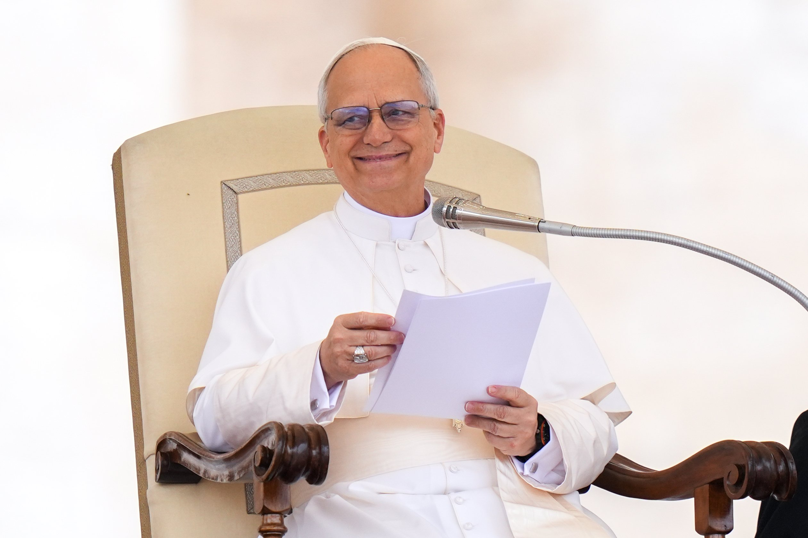
Dear brothers and sisters, when we participate in the Eucharist,
we are invited to listen to the Word of God and to be nourished at
the Lord’s table, where He offers Himself to the Father. These two
parts of the Mass, the Liturgy of the Word and the Liturgy of the
Eucharist, “are so closely connected with each other that they form
but one single act of worship” (SC, 56).
With regard to the Word of God, it is important to remember that it
is not merely a matter of acquiring intellectual knowledge of the
Scriptures, but of receiving the Word that is “living and effective” (Heb 4:12), spoken by God to everyone and at the same time to each individual. This Word nourishes and sustains us together with the Eucharistic Bread and leads us from the decay of sin to new life in Christ. “The Eucharist opens us to an understanding of Scripture, just as Scripture for its part illumines and explains the mystery of the Eucharist.” (Benedict XVI, Verbum Domini, 55).
The Second Vatican Council called for the treasures of the Bible to be opened more abundantly, so that a richer fare from the table of God’s Word might be provided for the faithful (cf. SC, 51). The liturgical reform translated this request into the treasure that is the Lectionary, the book that gathers all the biblical readings for liturgical celebrations. This richness has been drawn from the purest source of the living Tradition, which combines fidelity with tradition; with openness to legitimate progress (cf. SC, 23). Pope Leo XIV Wednesday Catechesis 24 June 2026

Sunday 5 July 14th Sunday in Ordinary Time

Sunday 12 July 15th Sunday in Ordinary Time

Sunday 19 July 16th Sunday in Ordinary Time

Sunday 26 July 16th Sunday in Ordinary Time

Sunday 5 July 2026 14th Sunday in Ordinary Time

Responsorial Psalm Ps 145(144):1-2. 8-9. 10-11. 13c-14. ℟ cf. 1

I WILL BLESS YOUR NAME FOR EVER, MY GOD AND KING.

I will extol you, my God and king,
and bless your name for ever and ever.
I will bless you day after day,
and praise your name for ever and ever.
How do we simply bless God for being God in our lives each day?
Think about what it will mean to praise God for ever and ever in heaven?

The LORD is kind and full of compassion,
slow to anger, abounding in mercy.
How good is the LORD to all,
compassionate to all his creatures.
Thank God for the times he has been kind and compassionate to you?
How do you show God’s kindness and compassion to others in your prayer and action?

All your works shall thank you, O LORD,
and all your faithful ones bless you.
They shall speak of the glory of your reign,
and declare your mighty deeds.
Reflect on how God established creation to meet all our needs?
Pray for all peoples to use creation for the common good and to secure humanity’s future

The LORD is faithful in all his words,
and holy in all his deeds.
The LORD supports all who fall,
and raises up all who are bowed down.
Pray that you can imitate God’s faithfulness and holiness in your life today
Pray for all who suffer from their mistakes and are bowed down. How will you to support them?

Sunday 12 July 2026 15th Sunday in Ordinary Time

Responsorial Psalm Ps 65(64):10a-d. 10e-11. 12-13. 14. ℟ Luke 8:8

SOME SEED FELL INTO GOOD SOIL AND YIELDED ITS FRUIT.

You visit the earth, give it water;
you fill it with riches.
God’s ever-flowing river brims over
to prepare the grain.
Pray for all those places where water is scarce and where people suffer drought
Pray for a successful harvest in our countries

And thus you prepare it:
you drench its furrows;
you level it, soften it with showers;
you bless its growth.
Pray for all who work on the land whose labours feed us
Pray with thanksgiving for the fruits of the earth we receive

You crown the year with your bounty.
Abundance flows in your pathways;
in pastures of the desert it flows.
The hills are girded with joy.
Pray for all small farmers and other stakeholders to benefit from their work
Pray for all who do not have enough to eat to be helped to obtain what they need

The meadows clothed with flocks.
The valleys are decked with wheat.
They shout for joy; yes, they sing!
Pray for all who keep livestock to gain from their care for their animals
Pray for all our rural parish communities to rejoice in their faith

Sunday 19 July 2026 16th Sunday in Ordinary Time

Responsorial Psalm Ps 86(85):5-6. 9-10. 15-16a. ℟5a

O LORD, YOU ARE GOOD AND FORGIVING.

O Lord, you are good and forgiving,
full of mercy to all who call to you.
Give ear, O LORD, to my prayer,
and attend to my voice in supplication.
Thank God for his mercy in the Sacrament of Reconciliation
Pray for something you need to develop your spiritual life

All the nations you have made shall come;
they will bow down before you, O Lord,
and glorify your name,
for you are great and do marvellous deeds,
you who alone are God.
Pray for the leaders of the world, those with power, to use it for the common good
Ask God to bring all warring nations to the peace that will glorify his name

You, O God, are compassionate and gracious,
slow to anger, O Lord,
abundant in mercy and fidelity;
turn and take pity on me.
Decide how to deliberately share God’s compassion and graciousness with someone in the coming days
Ask God to help people who struggle with anger to find ways to share his restraint

Sunday 26 July 2026 17th Sunday in Ordinary Time

Responsorial Psalm Ps 119(118):57, 72. 76-77. 127-128. 129-130. ℟97a

O LORD, HOW I LOVE YOUR LAW!

You, O LORD, are my portion;
I have promised to obey your words.
The law from your mouth means more to me
than large quantities of silver and gold.
Take some time to prayerfully reflect on the Ten Commandments and/or the Beatitudes
Ask yourself how often you think consciously about God’s law shaping your life

Let your merciful love console me
by your promise to your servant.
Show me compassion, that I may live,
for your law is my delight.
Identify some moments you can thank God for his merciful and compassion in your life so far
Pray for the gift to live his compassion for others?

That is why I love your commands
more than finest gold,
why I rule my life by your precepts,
and hate false ways.
Pray for the ability to embrace any of God’s commands which you find challenging or difficult
How does the Examen or anything similar fit into your daily prayer life?

Your decrees are wonderful indeed;
therefore my soul obeys them.
The unfolding of your word gives light,
and understanding to the simple.
Take time to unfold any passage of scripture to enlighten your way of life
Pray for a deeper love of meditating on the scriptures

