RESPONDING TO THE PSALMS – May 2026
a project of
the Spirituality Committee of the Bishops’ Conference of England and Wales

We use the Sunday Responsorial Psalm as a focus for prayer and reflection during the week ahead for yourself or to share with others.
You could note your own thoughts as a possible personal journal.

As we begin our Easter journey it would be good to stop and think what does this season mean to us and how we will use these Great Fifty Days as a time of grace.

In every part of the world, the Church lives as a people who
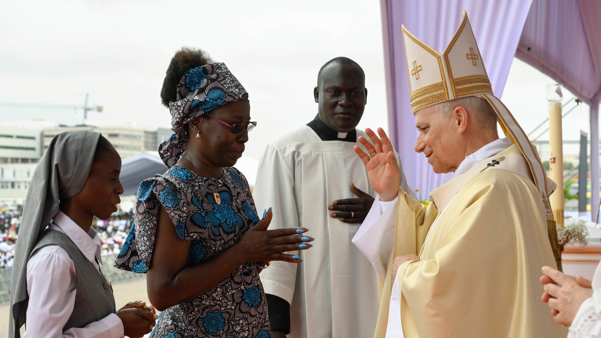
walk as disciples of Christ, our brother and Redeemer. He,
the Risen One, illumines for us the path to the Father and
with the strength of the Spirit he sanctifies us so that we
may transform our way of life in conformity with his love.
This is the Good News, the Gospel that courses through our
veins like blood, sustaining us on the journey. A journey
that has brought me here with you today! In the joy and
beauty of our gathering, united in the name of Jesus, let us listen with open hearts to the Word of salvation for it helps us reflect on the motive and purpose for which we follow the Lord………………
The Easter witness, therefore, certainly pertains to Christ, the crucified one who is risen, but it also pertains even to us because in him the proclamation of our resurrection finds its voice. We did not come into the world to die. We were not born to become slaves either to the corruption of the flesh or that of the soul: every form of oppression, violence, exploitation and dishonesty negates the resurrection of Christ, the supreme gift of our freedom. This liberation from death, in fact, does not happen only at the end of our days, but every day of our lives. What must we do to welcome such a gift? The Gospel itself teaches us: “This is the work of God, that you believe in him whom he has sent” (Jn 6:29). Yes, let us believe! Today, let us say it together with strength and with gratitude to you, Lord Jesus. We want to follow you and serve you in our neighbour: your word is our rule of life, the measure of truth. Pope Leo XIV – Angola, 21 April 2026

Sunday 3 May Fifth Sunday of Easter

Sunday 10 May Sixth Sunday of Easter

Thursday 14 May The ASCENSION of the LORD

Sunday 17 May Seventh Sunday of Easter

Sunday 31 May The Most Holy TRINITY

Sunday 3 May 2026 Fifth Sunday of Easter A

Responsorial Psalm Ps 33(32):1-2. 4-5. 18-19. ℟22
MAY YOUR MERCIFUL LOVE BE UPON US,
AS WE HOPE IN YOU, O LORD.

Ring out your joy to the LORD, O you just;
for praise is fitting from the upright.
Give thanks to the LORD upon the harp;
with a ten-stringed lute sing him songs.
Let us thank God for our clergy and all who lead our Eastertime liturgy
We thank God for all who sing and provide music for our celebrations

The word of the LORD is upright,
and all his works to be trusted.
The LORD loves justice and right,
and his merciful love fills the earth.
Let us thank God for all who proclaim the Word of God in our Mass
We thank God for all who, as Christians, care for those in need

Yes, the LORD’S eyes are on those who fear him,
who hope in his merciful love,
to rescue their soul from death,
to keep them alive in famine.
Let us thank God for all who care in our name for the dying and the bereaved especially in our local communities
We thank God for all who work in our name for those in need, especially Food Banks, SVP, CAFOD.

Sunday 10 May 2026 Sixth Sunday of Easter A

Responsorial Psalm Ps 66(65):1-3a. 4-5. 6-7a. 16, 20. ℟1
CRY OUT WITH JOY TO GOD, ALL THE EARTH.

Cry out with joy to God, all the earth;
O sing to the glory of his name.
O render him glorious praise.
Say to God, ‘How wondrous your deeds!’
Let us stop and wonder at the glory of God’s creation, at the beauty of the natural world.
We need to praise God for the amazing wonder of every unique human individual

‘Before you all the earth shall bow down,
shall sing to you, sing to your name!’
Come and see the works of God:
his wondrous deeds among the children of Adam.
Let us pray for all who work to promote ecology and sustain God’s creation
Let us thank God that we are sisters and brothers with all people throughout the world.

He turned the sea into dry land;
they passed through the river on foot.
Let our joy, then, be in him;
he rules for ever by his might.
Pray for all who work at sea in the Royal and Merchant navies, keeping us safe, supplying our needs
Just rejoice at being alive, trusting in God’s care for us

Come and hear, all who fear God;
I will tell what he did for my soul.
Blest be God, who did not reject my prayer,
nor withhold from me his merciful love.
Pray for the gift to communicate to others all that God has done for you
Pray for all who feel distant from or abandoned by God

Thursday 14 May 2026 The Ascension of the Lord A

Responsorial Psalm Ps 47(46):2-3. 6-7. 8-9. ℟6
GOD HAS GONE UP WITH SHOUTS OF JOY.
THE LORD GOES UP WITH TRUMPET BLAST.

All peoples, clap your hands.
Cry to God with shouts of joy!
For the LORD, the Most High, to be feared,
the great king over all the earth.
In our prayer let us applaud God for the great gift of hope in Christ’s Resurrection and Ascension
Thank God for the fact that he bothers with us at all.

God has gone up with shouts of joy.
The LORD goes up with trumpet blast.
Sing praise for God; sing praise!
Sing praise to our king; sing praise!
Take time to praise God in your prayer for God being God
Pray for ways to share/communicate the joy of our faith with other

For God is king of all the earth.
Sing praise with a hymn.
God is reigning over nations.
God sits upon his holy throne.
Pray for all world leaders to use the power God has given them for the good of all people
Pray for peace in the areas of conflict and war that you want to name before God

Sunday 17 May 2026 Seventh Sunday of Easter A

Responsorial Psalm Ps 27(26):1. 4. 7-8a. ℟13
I BELIEVE I SHALL SEE THE LORD’S GOODNESS IN THE LAND OF THE LIVING.

The LORD is my light and my salvation;
whom shall I fear?
The LORD is the stronghold of my life;
whom should I dread?
Pray for God to be your light in the decisions you need to make this week
Ask God to give you the strength you need to face up to your fears

There is one thing I ask of the LORD,
only this do I seek:
to live in the house of the LORD
all the days of my life,
to gaze on the beauty of the LORD,
to enquire at his temple.
Reflect on what heaven means to you now and as you journey through life.
Stop awhile and gaze on the beauty of God

O LORD, hear my voice when I call;
have mercy and answer me.
Of you my heart has spoken,
‘Seek his face.’
Ask God for his mercy and for all you need to live the Resurrection to the full
How do you seek to see God with your heart?

Sunday 24 May 2026 Pentecost

Responsorial Psalm Ps 104(103):1ab, 24ac. 29b-30. 31, 34. ℟ cf. 30
SEND FORTH YOUR SPIRIT, O LORD, AND RENEW THE FACE OF THE EARTH.

Bless the LORD, O my soul!
O LORD my God, how great you are!
How many are your works, O LORD!
The earth is full of your creatures.
Thank God for the Spirit you have received through the sacraments
Thank God for the people made in the image of God who enrich your life

You take away their breath, they die,
returning to the dust from which they came.
You send forth your spirit, and they are created,
and you renew the face of the earth.
Thank God for the breath of life you have received from him
Thank God for his creation

May the glory of the LORD last for ever!
May the LORD rejoice in his works!
May my thoughts be pleasing to him.
I will rejoice in the LORD.
Reflect on your life and see how it can give greater glory to God.
Rejoice in the Father, Son and Holy Spirit.
Sunday 31 May 2026 The Most Holy Trinity - Solemnity ●

Responsorial Psalm Dan 3:52. 53. 54. 55. 56. ℟52b
TO BE PRAISED AND HIGHLY EXALTED FOR EVER!

Blessed are you, O Lord, the God of our ancestors.
Thank God for all who have shared their faith with you in the past

Blessed is your glorious and holy name,
Pray “hallowed be your name” with new vigour

Blessed are you in the temple of your holy glory,
Thank God for churches and places that have brought you closer to God

Blessed are you on the throne of your kingdom,
Pray “Your kingdom come” with new vigour

Blessed are you who look into the depths, seated upon the cherubim,
Ask God to come into the depth of your heart and make his presence felt therein

Blessed are you in the firmament of heaven.
Pray the sign of the cross slowly and with commitment. Then pray the Glory be in the same way

