Saints of the Universal Faith

The Catholic Church is called universal because it belongs to people all over the world. Saints come from many different countries, cultures, and backgrounds, showing us that anyone can follow Jesus and live a holy life.

The Bible reminds us, “Whoever loves God must also love his brother and sister” (1 John 4:21), and the saints lived this out by caring for others and being faith filled and brave. Even though they were all different, they shared a love for God and for people, reminding us that we are one family and that everyone is called to live with faith, courage, and love.

Here are seven examples:

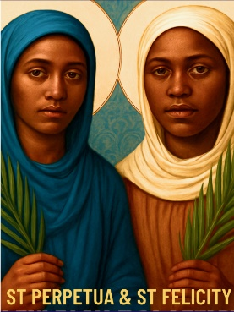
St Perpetua (c.181–203) & St Felicity (d.203)
Country: North Africa (modern-day Tunisia)
How they lived out their faith:
Perpetua and Felicity were early Christians who refused to deny their faith, even when imprisoned and sentenced to death. Felicity was enslaved and Perpetua was a young mother, yet they supported one another and stayed faithful to Christ with courage and hope.#

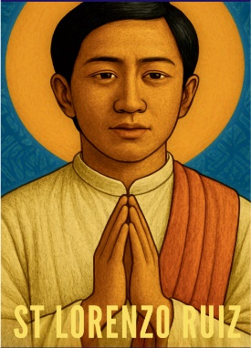
St Lorenzo Ruiz (c.1600–1637)
Country: Philippines
How he lived out his faith:
St Lorenzo Ruiz was a husband and father who served the Church as a layman. When persecuted, he refused to deny his faith, saying he would never turn his back on God. He showed strong faith, loyalty, and trust in God under extreme suffering.

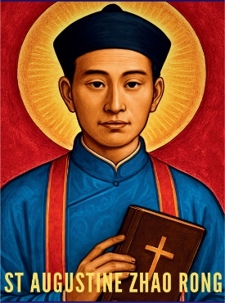
St Augustine Zhao Rong (1746–1815)
Country: China
How he lived out his faith:
Originally a soldier, Augustine Zhao Rong converted to Christianity after witnessing the faith of others. He later became a priest and continued to preach the Gospel despite persecution. He remained faithful to Christ even when it cost him his life.

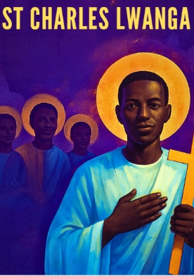
St Charles Lwanga (1860–1886)
Country: Uganda
How he lived out his faith:
St Charles Lwanga was a Christian leader who protected young people from harm and taught them about Jesus. He refused to give up his faith, even when threatened, and chose to stay faithful to God until his death. He showed courage, leadership, and love for others

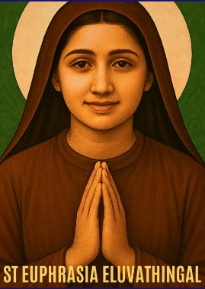
St Euphrasia Eluvathingal (1877–1952)
Country: India
How she lived out her faith:
St Euphrasia lived a life of prayer, service, and sacrifice as a Carmelite nun. She spent long hours praying for others and helping people who were suffering. Her faith was shown through humility, obedience, and deep trust in God.

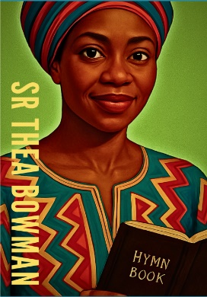
Sr Thea Bowman (1937–1990) (Servant of God)
Country: United States of America
How she lived out her faith:
Sr Thea Bowman was a Franciscan Sister who used her gifts as a teacher, speaker and hymn writer to share the Gospel. She worked for racial justice, inclusion, and dignity. Even when seriously ill, she continued to preach joy, hope, and love. She is currently in the process of being considered for canonisation.

