Mary - Mother of All
Blessed Mary is the mother of Jesus and the mother of all God’s people. As a result, she is shown in many different ways, using varied clothes, colours, and styles that reflect the cultures of the people who love her. These images remind us that everyone belongs in God’s family and that people live out their faith in different ways. Seeing Mary represented in different cultures helps pupils learn to respect differences and understand that the Church is universal and welcoming to everyone.
Suggested activities using diverse images of Blessed Mary
KS1
- Look at different pictures of Mary and talk about the colours, clothes, and faces they can see
- Share simple ideas about how the pictures show that God loves everyone
- Draw or colour a picture of Mary and talk about being kind and welcoming to others
KS2
- Compare images of Mary from different countries and identify similarities and differences
- Use a world map to locate where different images of Mary come from
- Create artwork showing Mary in their own community or school
- Write a short prayer thanking God for people from different cultures
KS3
- Explore how culture, history, and place influence how Mary is shown in art
- Discuss how these images reflect the Church as universal and inclusive
- Design a poster or digital presentation explaining one image of Mary and its cultural meaning
KS4
- Analyse how representations of Mary challenge racism and promote dignity and belonging
- Evaluate why it is important for the Church to show Mary in diverse cultural forms
- Write a reflective response linking Marian imagery to Catholic Social Teaching and human dignity
KS5
- Critically examine how Marian images relate to identity, culture, and theology
- Debate how diverse representations of Mary can counter ethnocentrism and racism within faith and society
- Research and present on a specific Marian title (e.g. Our Lady of Guadalupe) and its social, historical, and theological significance

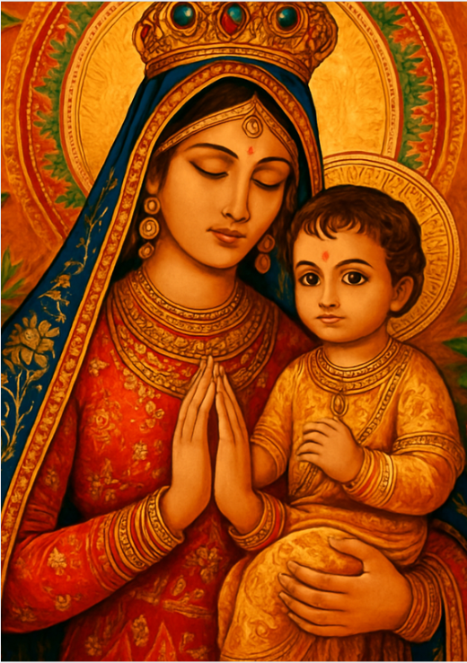
Mary – Mother of Jesus, India
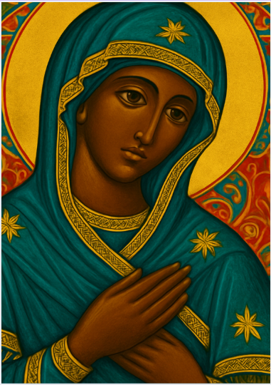
Black Madonna, Europe
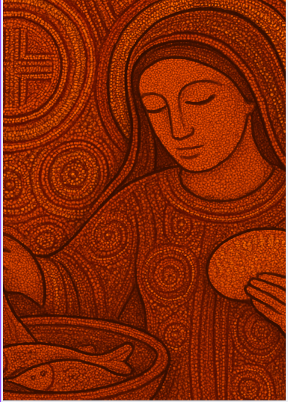
Mary – Giver of Nourishment, Aboriginal
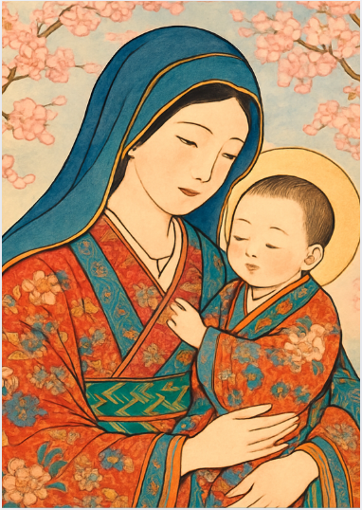
Mary – the Mother of God, Japan
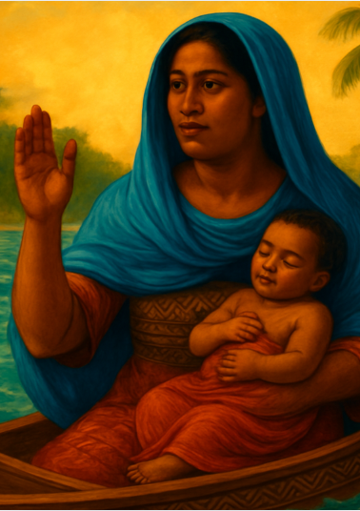
Mary - Our Lady of the Safe Harbour, Fiji
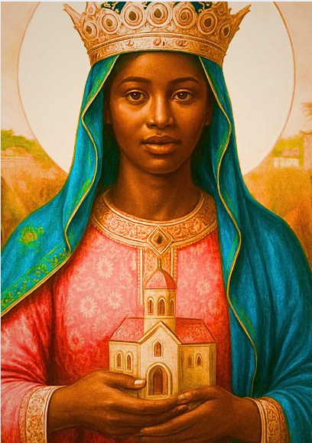
Mary - Mother of the Church, East Africa
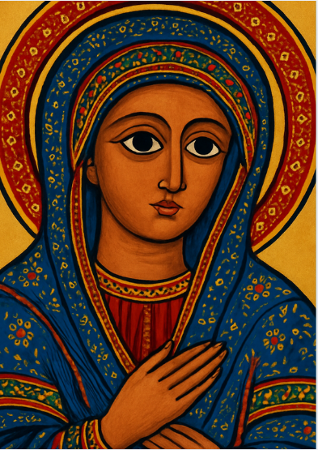
Mary – Our Lady, Ethiopia
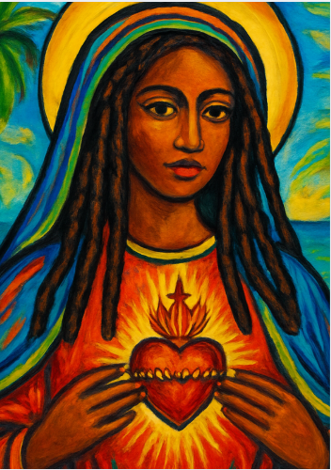
The Sacred Heart of Mary, Caribbean
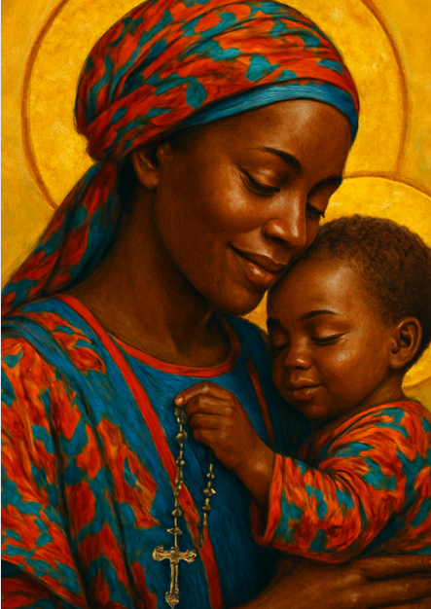
Mary – Bearer of Hope, West Africa
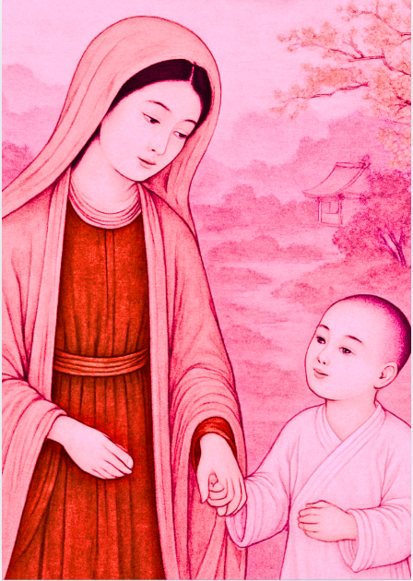
Mary -Mother of Perpetual Help, China

