Readers’ Notes

Saints Jerome and John the Baptist
National Gallery, London

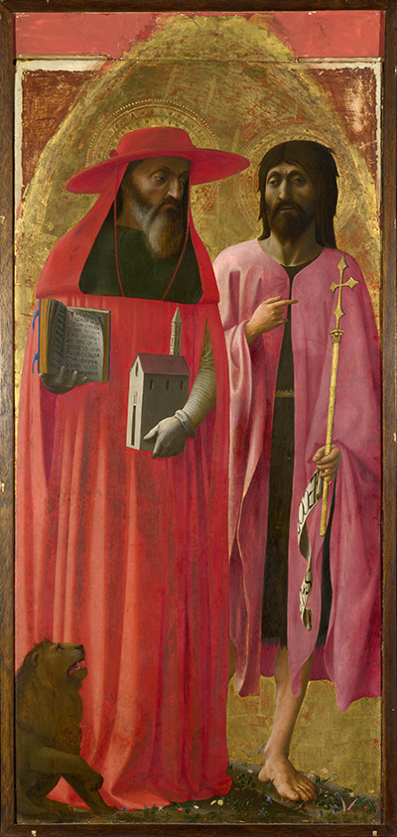
Painting title: Saints Jerome and John the Baptist.
Artist: Masaccio.
Date: Painted c.1428-9.
Location: Room 60, Sainsbury Wing, National Gallery.
Medium: Egg tempera on poplar.

https://www.nationalgallery.org.uk/paintings/masaccio-saints-jerome-and-john-the-baptist

Introduction

30 September is the feast of St Jerome and what better way to honour him than to be in his company right here at the National Gallery, in London. For Catholics all over the world, St Jerome is a very important saint and Biblical scholar. And in 2020, we’ll be celebrating the 1,600 anniversary since his death.

This picture of Saints Jerome and John the Baptist by the Renaissance artist Masaccio is one of two sides of a single panel that was divided into two and was commissioned for the Santa Maria Maggiore Basilica in Rome.
Who was St Jerome?
St Jerome was born in Dalmatia around 342 AD and died in 420 AD. As a teenager he moved to Rome where he became a Christian and prepared a translation of the New Testament from Greek into Latin. He continued this work in Bethlehem, translating most of the Old Testament into Latin from Hebrew. Together, these translations became known as the Vulgate and have shaped the Catholic understanding of the Bible ever since.
St Jerome believed that his work was a direct result of the Holy Spirit and produced a vast collection of commentaries and other writings that had great influence on Christian theology. With support from his friend St Paula he established monasteries for men and women but lived alone in a cell in Bethlehem. He also spent four years as a hermit, praying and fasting in the Syrian desert which is represented in many other paintings of him.

The Golden Legend
The Mediaeval and Renaissance iconography of St. Jerome derived from the popular Golden Legend book, written by Jacobus de Voragine, around 1260. The Golden Legend told the stories of the saints to whom people prayed. It was the mediaeval version of a soap opera! So, in the legends about St Jerome a number of events were appropriated into paintings of him. These include St Jerome in the wilderness, accompanied by a tame lion from which he pulled a thorn from its paw. In gratitude, the lion faithfully guarded and assisted St Jerome as we see here, and for the rest of his life.
Incorrectly, it is recorded that St Jerome was ‘ordained a cardinal-priest in Rome’ (the term cardinal wasn’t used before the 6th century). Therefore, he is usually dressed as a cardinal with a red cape and red flat-top cardinal's hat which Masaccio lavishly portrays here; making a rich and powerful statement aesthetically and ecclesiologically. As a Scripture scholar, St Jerome is always depicted with the Bible by which he receives divine inspiration from the Holy Spirit. Angels are believed to have visited Jerome regularly to help him with his commentaries, and with his failing eyesight; we might like to think of it as a sort of spiritual dictation.
Faith and vocation
If we look in detail at this wonderful and quite large painting of St Jerome – who dominates the canvas with his crimson red garments, we notice he holds two items: the Bible open at the book of Genesis in Latin, and a model of a typical 15th century Italian church. Jerome is one of the four Doctors of the Church, together with Ambrose, Augustine and Gregory the Great, and also, a Father of the Church. These two symbols of Bible and Church therefore, represent St Jerome’s life-long faith and vocation to the word of God.
St John the Baptist is also shown with some typical attributes, such as the coarse fur vest underneath a simpler garment, denoting his ascetic lifestyle. And look at the cross and a scroll with the words "Ecce Agnus Dei" - Behold the Lamb of God from John 1:29.
²⁹ The next day he saw Jesus coming toward him, and said, “Behold, the Lamb of God, who takes away the sin of the world! ³⁰ This is he of whom I said, ‘After me comes a man who ranks before me, because he was before me.’
John 1:29-30 (ESV)
To a careful observer, the cross sits on a Corinthian column, the emblem of the Colonna family, from which came Pope Martin V who was one of the popes during the artist - Masaccio's life, and of whom Masaccio would be keen to impress.
Light is the way
Both figures are more expressive than is usual for this period. Jerome looks stern and moody, while John is a bit scruffy, frowning and sorrowful. There are interesting folds in the fabric of their garments and the light dances in between the folds and on specific features – the light crossing Genesis chapter 1 to highlight the text, and again on Jerome’s fingertips through which his translation is written down, there is light on the church’s entrance to welcome the faithful in. The light also falls on Jerome’s left arm and on John the Baptist’s right shoulder perhaps indicating that we are all of one body when we come together in Christ; and the lights dazzles the gold cross and banner to prophesy Christ’s arrival and death.

St. Jerome - the famous priest and theologian of his time, and St. John the Baptist – a mysterious prophet of two different worlds – that of Israel from which he came and that of Christ from which he would foretell, stand larger than life and emerge from out of the frame of this painting. Their spiritual stature is too big to contain here, nevertheless, we gaze at them chatting away, two giants of our Church who have much to consider in this unique encounter.
Scripture, Church and Tradition
We see that while St Jerome holds the Bible in his right hand and the church in his left - that he holds the Bible higher than he does the church. The Church is at the service of the Bible. And the Church is the Bible’s interpreter and curator. Together, the Bible, the Church and Tradition, as embodied by St Jerome, quite literally go hand in hand! If we look more carefully, St Jerome is looking directly at the cross and St John is looking beyond the painting into the distance but pointing with his right forefinger to the cross. Diagonal lines from St Jerome’s eyes, the Bible and the Church, and even the lion all finish at the cross! Since Ignorance of the Scriptures is ignorance of Christ, says St Jerome.
Both St Jerome and St John prepare the way of the Lord. St Jerome through Scriptural translation to make the word more accessible, and St John the Baptist in living humbly, prophetically preaching to the crowds and dying for his faith. Here they stand on a grassy verge, with flowers in bloom - when we stand together in faith, our life can begin to blossom.
The God who Speaks: The Year of the Word
Through this campaign, we invite you to encounter Christ’s love more deeply through the Scriptures. May you thirst for God’s Word; listen to God speak into your hearts and into your lives; experience ever more imaginative and creative ways of opening the Bible; discover the greatest story ever told; walk through the Old Testament; sit with Mary and the disciples; bow down at the cross and rejoice at the resurrection of Christ. May we all be enriched and renewed by this special year, and together, let us share the love of Christ to the ends of the earth.

Opening Prayer
Pilgrim God,
you walk alongside us
and speak to us throughout the Scriptures:
in the message of the prophets,
the songs of David
and the vision of Paul.
Your Son, Jesus Christ, listens to our hopes and fears
and shows us how to live:
in our love of neighbour
our desire for justice,
and in our dying and rising each day.
Send us the Holy Spirit to open our hearts and minds
so that we may be your witnesses throughout the world:
in our protection of the vulnerable,
our words and actions
and in our communion with the earth.
Amen

Questions
What strikes you about this painting?
How might St Jerome and St John the Baptist enrich your faith?
Looking at the Bible and Church in St Jerome’s hands, what can we be inspired to do in our
parishes and communities?
How can we make these ideas happen?

Closing Prayer
Our Father…
Hail Mary…
V. Your word is our path and your truth is our light.
R. This day and every day.

Our Lady of the Annunciation pray for us
St Matthew pray for us.
St Jerome pray for us.
Amen.

