REGENERATION
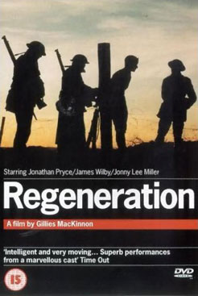
UK, 1998, d. Gillies McKinnon



During World War I, Dr William Rivers is in charge of a psychiatric
unit in Scotland. A sympathetic man, he gives himself
completely (even to identifying with patients in dreams) to the
recovery of shell-shocked and traumatised soldiers.

In his care is the poet, Siegfried Sassoon, who has written
anti-war letters to the government while still willing to fight at the
front. Another is the younger poet, Wilfrid Owen. Other
hospitalised soldiers include Billy Prior who has lost his power
of speech and whom Rivers guides back to face the horror of
his ordeal in the trenches.

Sassoon helps Owen with his poetry. Sassoon refuses to face a tribunal but Rivers pleads his case and Sassoon returns to active service. Owen also goes to France where he is killed in action. Prior is given leave and meets a young woman called Sarah with whom he has an affair.

Dr Rivers goes to London to witness Dr Yealland using shock therapy on soldiers. Yealland makes forcible demands on the will of his patients to effect their cure. Dr Rivers finds this too brutal and returns to Scotland to continue his work at the hospital.

Regeneration has been adapted from the first in a trilogy by Booker Prize winning novelist, Pat Barker. (She won the Booker for the third novel in the trilogy, The Ghost Road.) Director is Scott Gillies McKinnon who has made a variety of films including Small Faces, Hideous Kinky and A Small Twist of Fate, an adaptation of Silas Marner with Steve Martin.

The centre of attention of the movie is a psychiatric unit. A great deal of the running time shows Dr Rivers treating his patients. Poets Sassoon and Owen are based on actual characters and the movie shows their friendship and creative writing. Billy Prior is fictitious (and his character is a great deal simplified from the novel).

There are many harrowing sequences, not only the therapy sessions but Rivers' dreams of Rivers and those of his patients as well as flashbacks to the trench warfare, especially the episode concerning Billy Prior and a dead man's eye. The movie changes visual style and editing for these sequences. Quite horrific is the extended sequence of the confident doctor who uses shock treatment for his patients.

However, the tone of the movie is also one of hope for healing, especially with its title, 'Regeneration'.

