Reconciliation Service

Sign of the Cross
Introduce why we make the sign of the cross; to state our belief in the Holy Trinity. And for the sacrifice Jesus made on the cross for us (If a crucifix is present then that would be perfect for imagery!)
Let’s have a moment of silence to recognise the presence of God with us. God is with us always but it’s during these times of prayer where we have the chance to really listen to what God is trying to say to us.

Opening Prayer
You could write your own opening prayer, but below is an example of one that can be used.
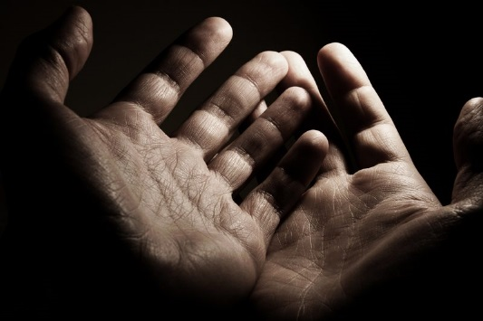
God, our father, You sent Your only son to proclaim a time of mercy, reaching out to those who had no voice and welcoming those scorned by society. Open our ears, so that we may listen with respect and understanding. Heal us, so that we can speak your words of peace and forgiveness. Restore and strengthen us through your son, Jesus Christ, Our Lord. Amen.

Scripture- Luke 23:35-43
This is the Gospel reading for National Youth Sunday
The people stayed there before the cross watching Jesus. As for the leaders, they jeered at him. ‘He saved others,’ they said ‘let him save himself if he is the Christ of God, the Chosen One.’ The soldiers mocked him too, and when they approached to offer him vinegar they said, ‘If you are the king of the Jews, save yourself.’ Above him there was an inscription: ‘This is the King of the Jews.’ One of the criminals hanging there abused him. ‘Are you not the Christ?’ he said. ‘Save yourself and us as well.’ But the other spoke up and rebuked him. ‘Have you no fear of God at all?’ he said, ‘You got the same sentence as he did, but in our case we deserved it: we are paying for what we did. But this man has done nothing wrong. Jesus,’ he said ‘remember me when you come into your kingdom.’ ‘Indeed, I promise you,’ he replied ‘today you will be with me in paradise.’

Unpacking the Scripture
There are many ways to unpack this piece of scripture. A few are listed below or you could refer to the readings part of the document where there are more ideas on the readings and Gospel for National Youth Sunday.
- We are so often pulled in to be part of the crowd, and be there to ‘persecute’ somebody for doing something that we think is wrong
- We are called to be like the other criminal, and to stand up for what we believe in
- Part of this is to recognise our mistakes and the things we do that hurt others.
- It’s an easy option to fit in, but God never said it was going to be easy, and that’s why we are challenged to be better people each day.
- ‘Today you will be with me in paradise.’- When Jesus said this, he makes the other criminal the first ever saint! The first person welcomed into Heaven. We are all called to be saints and getting into Heaven is how we achieve that. We only enter Heaven when we are free of sin
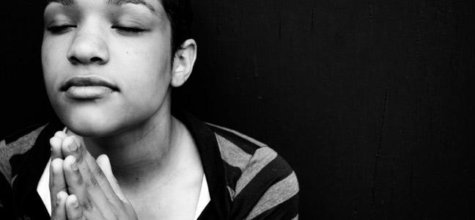
Link into reconciliation
There are many ways you can link this scripture to reconciliation. Below is an example of what could be said, however if you would like to write your own to make it more personal that would be fine.

We only enter Heaven when we are free of sin. Every time we go to confession, our sins that we are really sorry for are forgiven and cleansed. Therefore when we leave the confession, we are saints!

Examination of Conscience leading to an opportunity for the Sacrament of Reconciliation
- Examination of conscience PowerPoint provided in document
- Write your own examination!
- Google ‘examination of conscience’

After you have shown/read the examination, you could read the following whilst leaving the examination on a loop in the background;
You are going to have the opportunity to become a saint now. If you are worried about what to say, don’t be scared to ask the priest! He’ll help you and guide you along in your confession. If you feel like you don’t know what you want to confess or think you have nothing to confess, please watch the PowerPoint on the screen. This slideshow is what is known as an examination of conscience. This gives us the chance to think about all of the things we have done that may have hurt others. When you feel like you are ready, please make your way to whichever priest you would like to make your confession to.

Prayer Stations
The inclusion of Prayer Stations can be a useful tool within a reconciliation service.

Offering Prayer
This is a chance to offer our thanks after confession. Using Mary is a perfect example as Mary lived without sin! Below is an example of one you could use;

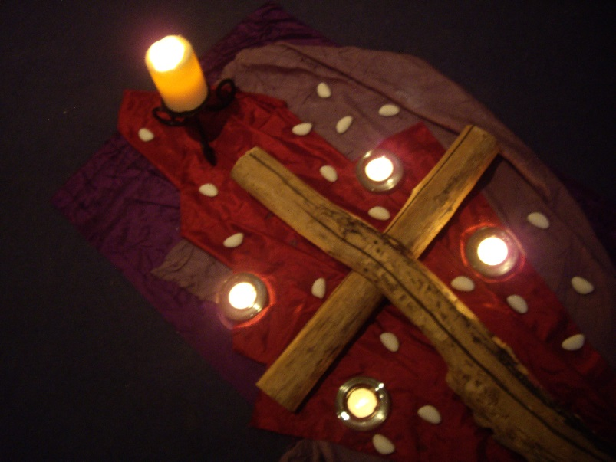

The mother of our Lord Jesus Christ lived her life without sin. We ask Mary to guide us on our Journey as we try to also live our lives in this way, especially in the times we find it difficult. We offer our thanks for God’s love through the intercession of Mary, our mother, as we say, Hail Mary….

Closing Prayer
You could write your own closing prayer, but below is an example of one that could be used.
Almighty and ever loving Father,
We thank you for your mercy.
Lord, we pray that through Your forgiveness we can forgive others who have hurt us.
Lord we ask that You continue to lavish Your love upon us Your children
And that through this Sacrament of Reconciliation we can grow ever closer to You.
We ask this prayer through Christ our Lord.

Amen

