A few icebreakers

Just a couple of games to help young people prepare to reflect on the scriptures.
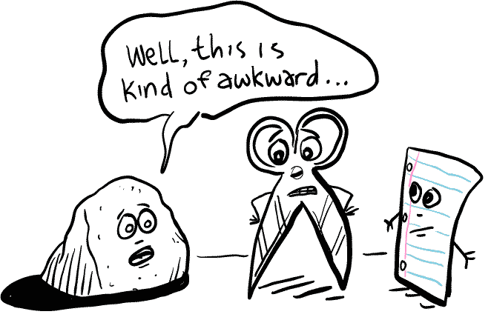
A take on rock, paper, scissors...
They say that there is no such thing as a new idea. In this case that is certainly true. Rock paper scissors has given us two excellent icebreakers to share with young people. The beauty with these games is that they are simple and familiar.
Evolution
This game works best with a large group of young people. They will be taught a series of stages, or levels of evolution. These could be anything;

Egg | Leper
Chicken | Beggar
Eagle | Rich Man
Dragon | Disciple
Superhero | Saint

It might be nice to teach an action to the young people to show how they might progress through the stages. This is a race for the top, in pairs young people will all begin at the bottom rung of the ladder. In this example lets say that they are eggs, they will then be told to find another egg. To “evolve” they must beat another egg in a game of rock, paper scissors. The winner evolves into a chicken, the less successful competitor stays an egg. (in this game you don’t de-evolve for not winning) this is a race to see who becomes a superhero/saint first.

Of course this is a ridiculous example, but is does open the conversation up to talking about the complimentary (rather than clashing) baptismal offices as priest, prophet and king.

Priests, Prophets and Kings
Again using a similar premise as rock, paper, scissors. This is also played as one of many variations, perhaps you have heard of it as giants, pixies, wizards. Again you will need to create an action for these roles. You will also need to decide how each role might defeat another.

Wizard beats Giant Prophet advises King
Giant steps on Pixie or King rules Priest
Pixie tickles Wizard Priest blesses Prophet

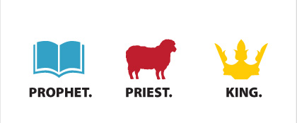
Break the whole group into an even number of small groups, be it 2, 4 or 8 groups. And asked to appoint a captain, they will then be told against whom they will compete. The leader of the game will announce how many young people will compete each round, between 1 and 5 young people depending on the pace of the game. The captain may not compete unless they absolutely have to, they will be given a moment or two to decide who to send and what move they will all play. (if you have five competitors from a team they must all play the same move). If both teams play the same move then it is a draw, everyone goes back to their starting spots. If one team beats the other they will take the spoils of battle, they will now add their opponents to their own team. Once a team has lost all of their people they will be totally absorbed. In the end only two massive groups will remain, by this point you may want to have more than five young people compete. If you are looking for a quick finish against two equal sizes you may choose to ask the captains to face off, the winner takes all.

Scripture scramble
Split the small group into sub-groups of three to four young people. Each group needs to be given a Bible. When they are ready the session leader must read out a particular Bible reference. The first group to find that reference and read it out will receive a point. All of these references are linked by the theme of kingship, but let’s see whether they spot it. Here are some examples:

2 Kings 19:19 “Now, LORD our God, deliver us from his hand, so that all the kingdoms of the earth may know that you alone, LORD, are God.”
2 Peter 1:11 And you will receive a rich welcome into the eternal kingdom of our Lord and Saviour Jesus Christ.
Acts 17:7 They are all defying Caesar’s decrees, saying that there is another king, one called Jesus.
The same game can be played in reverse for round two. They can be given a word and have to find as many references as possible, for example, prayer, love or forgiveness.
Revelation 19:16 On his robe and on his thigh he has this name written: King of kings and Lord of Lords.
Mark 15:2 “Are you the king of the Jews?” asked Pilate. “You have said so,” Jesus replied.
Matthew 13:24 Jesus told them another parable: “The kingdom of heaven is like a man who sowed good seed in his field.
John 19:19 Pilate had a notice prepared and fastened to the cross. It read: Jesus of Nazareth: The King of the Jews
1 Timothy 6:15 “God, the blessed and only Ruler, the King of kings and Lord of lords”
Daniel 2:37 “Your Majesty, you are the king of kings.”
Psalm 68:32 “Sing to God, you kingdoms of the earth, sing praise to the Lord”
Revelation 1:5 and from Jesus Christ, who is the faithful witness, the firstborn from the dead, and the ruler of the kings of the earth.

