His Eminence Cardinal Gabriel Zubayr Wako, Archbishop of Khartoum, President of the Sudanese Catholic Bishops Conference

C/O Mrs Jane Andanje
CAFOD Representative, Juba

By Email: jandanje@cafod.org.uk
Monday 27th January 2014

Your Eminence,

As you know, we the Bishops of England and Wales have been following the work of the Church in Sudan and South Sudan for a number of years both as a Conference and through our agencies: Aid to the Church in Need UK; CAFOD and Missio UK. We have also asked Bishop William Kenney to represent us in following the situation more closely and he has already undertaken a visit to Juba and continues to attempt to organise a visit to Khartoum.
In light of your call on political leaders to make serious attempts to broker peace and alleviate the suffering of those caught between the warring factions, we would like to add our voice to that of the AMECEA bishops in assuring you of our prayers and support
We have also been encouraged to see the ecumenical commitment of Church leaders in South Sudan under the leadership of the Catholic and Episcopalian Archbishops of Juba.
While the Sudanese Catholic Bishops Conference remains one, your responsibility covers two sovereign nations each with its own challenges. We feel that it would be remiss of us if we were to omit assurances of our ongoing support and prayer for the different challenges that you face in Sudan.
We join you in prayer as you continue your meeting in Juba, asking that the Holy Spirit inspire you and give you strength.
Greetings to you and your brother bishops with assurance of my prayers and support.
Yours in Christ
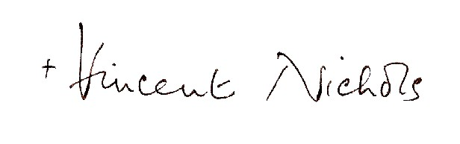
+Vincent Nichols
Archbishop of Westminster, President of CBCEW

