WORLD COMMUNICATIONS DAY
Sunday 2 June 2019

Dear Father,
“We are members one of another” (Eph 4,25).
From social network communities to the human community

As Bishop for Communications, once again on this special day of prayer for all those working in tech, the media, creative and communications industries, I’m delighted to bring your attention to the crucial work of the Communications Office of the Catholic Bishops’ Conference of England and Wales.

In his message for this day, Pope Francis invites us to reflect on the foundation and importance of our 'being-in-relation' and to rediscover, in the challenges of the current communications context, the desire of the human person who does not want to be left isolated and alone. While governments seek legal ways to regulate the digital world and to protect the original vision of a free, open and secure network in the worldwide web, we all have the possibility and the responsibility to promote its positive use.
We can always seek new, innovative ways to share and promote the joy of the Gospel. Those specifically dedicated to this work, such as the Diocesan Communications Officers and the small team at the Bishops’ Conference do an inspiring job with few resources. I’ve particularly enjoyed the recent Podcast series Luke in Lent, produced by the Communications Office at the Bishops’ Conference. The work around the Youth Synod has filled me with hope. The photos recording the events of the life of our Church are freely available to anyone who wishes to use them - and some 49 Million people across the world have already done so, this is a great resource for your parish and community.

These moments captured by our photographer make wonderful reminders of so many great events.

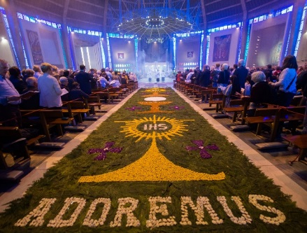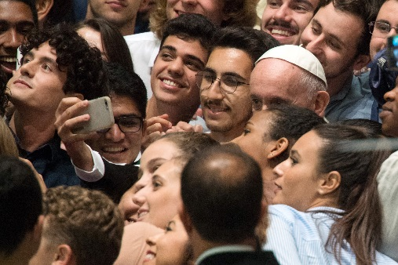

Please encourage your communities to assist this crucial work by their generosity to the collection which is taken today. Please visit and encourage others to visit www.catholicnews.org.uk and if you would like to sign up for the twice daily news bulletins, please e-mail ccn@cbcew.org.uk

With every blessing,

+John Arnold, Bishop of Salford PTO

PARISH RESOURCES AND INFORMATION
Please distribute these prayer cards to mark World Communications Day, with an invitation to pray for the work of all those engaged in the worlds of the media, tech, creative and communications industries and the Communications Office of the Bishops’ Conference. Resources for parish newsletter inserts, homily notes and suggested bidding prayers are available at http://catholicnews.org.uk/wcd19

PARISH COLLECTION FOR WORLD COMMUNICATIONS DAY
Parish collection monies should be sent to your Diocesan Finance Office, according to the procedures applicable in your diocese, for forwarding to CaTEW.

Individual donations by cheque should be made payable to your parish. These can then be paid-in and accounted for on your parish weekly income record as a donation to a second collection and incorporated within the total sum.
There is also the possibility of donating online at http://www.catholicnews.org.uk/donate-wcd

Message of His Holiness, Pope Francis for World Communications Day 2019: http://www.catholicnews.org.uk/wcd19-pope-message

