WORLD COMMUNICATIONS DAY
Sunday 13th May 2018

Dear Father, Brother and Sister,

“The truth will set you free” (Jn 8:32) Fake news and journalism for peace

In his message for World Communications Day 2018, Pope Francis speaks of journalists as “the protectors of news.” That their task is “not just a job; it is a mission.” He reminds us that persons are at the heart of information, that informing others means forming others; “That is why ensuring the accuracy of sources and protecting communication are real means of promoting goodness, generating trust, and opening the way to communion and peace.”
On this World Communications Day, we pray for those who work in the media and also for the valuable work carried out on our behalf by the Communications Office of the Bishops’ Conference. Working with journalists across both national and international media outlets, it provides a professional news service to the Church and to the world.

Using the latest digital channels, the team create and promote engaging and inspiring Catholic content, including short films, podcasts, and events. Their award-winning audio and podcasts can be found on SoundCloud and audioBoom. ‘Schools of Prayer’, a podcast series on Catholic religious communities and the great saints that founded them, has been played almost 25,000 times.

Recently, the Communications Office played a key role in securing a special investigation into the scourge of modern slavery with the Evening Standard and the Independent. Pope Francis was presented with the Evening Standard’s “Slaves on Our Streets” report at the Vatican.

They also developed and built a new digital initiative called the Art of Dying Well – www.artofdyingwell.org, aimed at helping terminally ill people and their loved ones’ deal with death. It has been described in the Guardian ‘as contributing to society’s communal well-being’.

Their free photos on Flickr highlight the Church’s work and witness on a local and global level – www.flickr.com/catholicism These photos are downloaded, shared and published by millions of people and publications (Catholic and mainstream) across the world and are available to you for your parish websites and publications – please just credit ©Mazur/www.catholicnews.org.uk

Finally, they worked behind the scenes with broadcasters and print journalists in announcing the news of Cardinal Cormac Murphy-O’Connor’s death and in the preparation of the obituaries. They also organised a breakfast briefing to help inform journalists from the mainstream and Catholic press on the meaning behind Catholic funeral rites.

Please encourage your communities to assist this work by their generosity to the collection which is taken today, enabling the Church to continue this work of communication. Please visit and encourage others to visit www.catholicnews.org.uk and if you would like to sign up for the twice daily news bulletins, please e-mail ccn@cbcew.org.uk

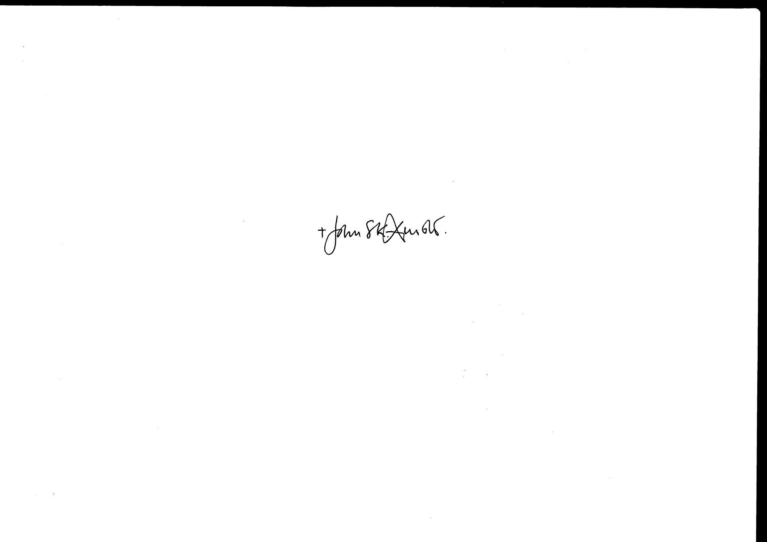
With every blessing,
+John Arnold, Bishop of Salford PTO/

PARISH RESOURCES AND INFORMATION

Please distribute these prayer cards to mark World Communications Day, asking for prayer for the work of the media and the Communications Office of the Bishops’ Conference. Resources for parish newsletter inserts, homily notes and suggested bidding prayers are available at http://catholicnews.org.uk/wcd18

PARISH COLLECTION FOR WORLD COMMUNICATIONS DAY

Parish collection monies should be sent to your Diocesan Finance Office, according to the procedures applicable in your diocese, for forwarding to CaTEW.

Individual donations by cheque should be made payable to your parish. These can then be paid-in and accounted for on your parish weekly income record as a donation to a second collection and incorporated within the total sum.
There is also the possibility of donating online at http://www.catholicnews.org.uk/donate-wcd

Message of His Holiness Pope Francis for World Communications Day 2018: http://ow.ly/HbZJ30iZqgu

