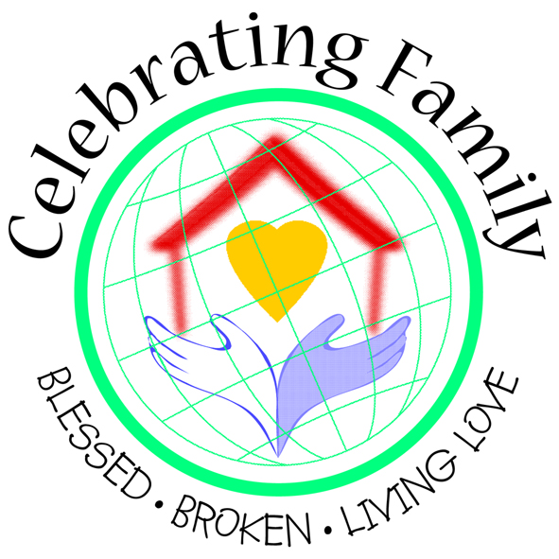
Marriage and family life
project resources
Available to purchase from the Project Office to support
Celebrating Family in your parish, school, deanery or diocese

Name. Date.
Address.

Parish/School/Organisation.
Email address.
Would you like to receive the MFL E-Bulletin monthly to keep in touch with project developments? Y □ N □

Item | Price | Quantity | Total  Price
Home is a Holy Place DVD | £5 each
What Life is Like? A set of 7 leaflets for parish groups to support families in challenging circumstances | £2 per set
Home is a Holy Place postcards – for sending feedback  to Bishop John Hine | £5 per 50
Home is a Holy Place prayer card: Love | £7 per 100
Home is a Holy Place prayer card: Relationships | £7 per 100
Home is a Holy Place prayer card: Creation | £7 per 100
GRAND TOTAL

Please make cheques payable to Colloquium (CATEW) Ltd and send completed form with payment to:
Marriage and Family Life Project Office, CBCEW, 39 Eccleston Square, London SW1V 1BX

OFFICIAL USE ONLY:
Payment Received: Total. Date. Initials.
Goods Supplied Total. Date. Initials.
Colloquium (CATEW) Ltd. Company number:4735081. Registered address
39 Eccleston Square, London SW1V 1BX. Registered in England and Wales

