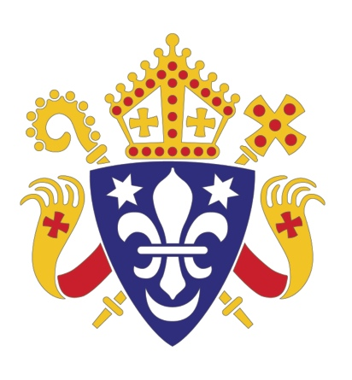
Catholic Bishops’ Conference of England and Wales
HOME MISSION SUNDAY: 21 SEPTEMBER 2014
PARISH EVANGELISATION STORY:
ST MARY’S ON THE SEA WITH ST JOHN FISHER PARISH, GRIMSBY
Supporting ministry and outreach to non churchgoing (lapsed) Catholics

From April 2013 – July 2014 the parish of St Mary on the Sea with St John Fisher Parish in Grimsby, took part in a Bishops’ Conference pilot project to support the creation and running of parish evangelisation teams. The project was called Crossing the Threshold and aimed to help parishes develop outward-facing activities in service of local evangelisation. A particular focus of the project was ministry and outreach to non churchgoing Catholics.

NEW LIFE AT EASTER

During Easter 2014 several activities took place. Parish Priest, Fr Joe Wheat, shares some highlights.

The Hidden Gem
The second edition of our parish magazine was printed and distributed to over 400 families and individuals in the parish and local area. It contained articles on parish life, memories from childhood, details of Easter services, articles on Pope Francis, our local Catholic secondary school and much more.


Palm Saturday Children’s Activities
Led by a team of Crossing the Threshold volunteers, primary school staff and parishioners, we invited children from the parish and primary school, and the local area, to come to the school hall and into the church for a morning of activities for them and their parents that included: an Easter Egg Hunt in the church, Easter card making, egg painting, flower making, creating and decorating Easter bonnets and baskets. The hall was awash with paint and glitter! Refreshments were served for children and parents and the prizes in the egg hunt were very popular! The team predicted about 20 – 40 children would come along, but we were amazed when over 80 children came, dragging their parents and grandparents along! Plans are already being made for a similar event around harvest time.

Good Friday Walk of Witness
Although a feature of church life in most towns and villages, Grimsby had not held a public act of witness for Good Friday for several years, and it had certainly never been led by St Mary’s in our local area of the East Marsh. The Crossing the Threshold team decided to rectify this so set about working with two of our neighbouring churches. The route was planned, a stewarding company engaged to keep us safe, and the event was advertised throughout our parish, school and local area. Anticipating about 20 people turning up, everyone was really pleased to see over 80 people assemble. Starting outside St Mary’s, we then set off on our route down one of the main shopping streets in Grimsby. After stopping for prayer at a couple of points, we ended up with a short service in the middle of the local covered market. Along the way we distributed flyers inviting people to come to our Easter services and also gave out vouchers for a cup of tea and a hot cross bun – a lovely way of wishing people ‘Happy Easter’ and giving them a treat from the local Christian community.
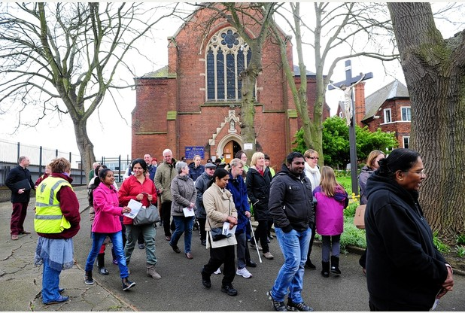
Easter celebrations
Good Friday Walk of Witness
Part of the Crossing the Threshold project is aimed at inviting people to join the parish for key celebrations such as Christmas and Easter. It is very difficult to gauge the success of any invitation or outreach, but here at St Mary’s, we have one way of seeing if our evangelisation has any impact. At each service, someone counts the congregation. These figures are noted and then retained going back several years. So, if it is a good measure of ‘success’ is dubious, but the numbers of ‘people in the pews’ might tell us if we are doing something right. Here in our parish, we saw a doubling of numbers at the Holy Thursday evening Mass of the Lord’s Supper. This 100% increase was also seen at the Easter Vigil and on Easter Sunday morning. So we might be doing something right, may not be sure what that is, but hope that those who came along had a good experience of community, went away with their faith strengthened and received a deeper sense of belonging to the Body of Christ, made visible in the congregation at St Mary on the Sea and St John Fisher.

With thanks to the Nottingham Diocese and all the participating parishes for hosting the pilot project.

Interested in starting an evangelisation team in your parish?
Please contact your diocesan evangelisation staff (office), or the Bishops’ Home Mission Desk, if you’d like to talk through ideas about starting a parish-based team. A number of free resources are available under the banner of the Bishops’ Conference ‘Crossing the Threshold’ project.
Email: homemission@cbcew.org.uk

Home Mission Sunday is resourced by the Bishops’ Conference Home Mission Desk in service of the Department for Evangelisation and Catechesis. Email: homemission@cbcew.org.uk www.catholicnews.org.uk

Catholic Trust for England and Wales, 39 Eccleston Square, London, SW1V 1BX.
A company limited by guarantee and registered in England and Wales. Company No. 4734592 Registered Charity No. 1097482.

