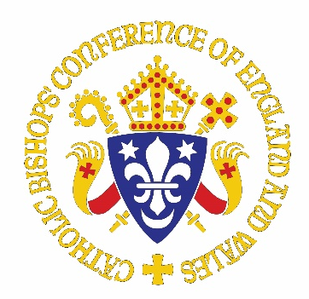
Letter to parish priests in anticipation
of Home Mission Sunday

Dear Father,

Firstly, thank you for the many ways in which you and your congregation is responding to this challenging time and the restrictions we encounter in the face of the pandemic. I have heard of heroic efforts to reach out to people through physical, emotional and spiritual support. I want to encourage you in this effort, as we prepare to celebrate Gaudete Sunday and Home Mission Sunday together this year on 12th – 13th December.

You will know that Evangelisation is an essential work of the Church. At all levels, and through every avenue we can utilise, we are called to share the good news of Jesus Christ. We do so, in order that others may come to know the beauty of encountering Him. Because of the broad and varied expressions of this mission, every now and then, we need to refocus on what we are trying to achieve. This is what Home Mission Sunday is about. During the first lockdown, the Bishops decided to move Home Mission Sunday from September to 13th December, in the hope that it would be a better time to engage the Faithful in this important work. Providentially this year, we are marking Home Mission Sunday at a time when we are all trying to encourage as many people as possible to return to the practise of their faith, now that there is the possibility of being physically present for Mass once more.

The resources for Home Mission Sunday this year are intended to inspire and equip communities, families and individuals to share their faith, in this period leading up to Christmas and beyond. They can be found on homemission.org.uk/home/events/home-mission-sunday/

There you will see that we are sharing individual stories of encounters with Christ and the different ways in which some have chosen to follow Him. These stories can also be found on our social media platforms in the run up to Gaudete Sunday. Please click on the icons below to follow Home Mission. I encourage you to share any that inspire you, through your own parish social media platforms.

Finally, I would like to let you know that we welcomed Fr Jan Nowotnik, a priest of the Archdiocese of Birmingham, as Secretary to the Department for Evangelisation and Discipleship in September. Should you have any queries regarding Home Mission Sunday or the work of the Department, then please do email him at jan.nowotnik@cbcew.org.uk or our Home Mission Development Officer, Teresa Carvalho via teresa.carvalho@cbcew.org.uk.

With my kindest wishes and prayers.

Yours devotedly,


This Photo by Unknown Author is licensed under CC BY-SA



Rt Rev Mark O’Toole
Bishop of Plymouth
Chair of the Department for Evangelisation and Discipleshi

